***MAKE A PRESENTATION – BSBCMM401***

**VIDEO & IMAGES LOG**

**VIDEOS**

**UNIT – MAKE A PRESENTATION**

1. VIDEO 1 - Introduction by Des (New Video)

* Intro to Unit

**TOPIC 1 – PREPARE A PRESENTATION**

1. VIDEO 2 - Introduction by Des (New Video)

- Intro to Unit and intro to Topic 1.

- Include a Story on presenting as the link into topic.

1. VIDEO 3 - Story for either understand your audience by Des (New Video)
2. VIDEO 4 - Impromptu SOSOR by Des (Update existing Video)
3. VIDEO 5 - Closing off topic 1 and assessment instructions by Des (New Video)

**TOPIC 2 – DELIVER A PRESENTATION**

1. VIDEO 6 – Introduction by Des (New Video)

- Intro to Topic 2 – Using SOSOR

1. VIDEO 7 - The Art of Storytelling by Des (New Video)
2. VIDEO 8 - Hostile Crowds by Des (Update existing video)
3. VIDEO 9- Closing off topic 2 and assessment instructions by Des (New Video)

**TOPIC 3 – REVIEW THE PRESENTATION**

1. VIDEO 9 - Introduction by Des(New Video)

- Intro to Topic 3 – Using SOSOR

1. VIDEO 10 - Ric Elias – 3 Things I learnt whilst my plane crashed (existing TED clip)
2. VIDEO 11 - Closing off topic 3 and unit BSBCMM401 and assessment instructions by Des (New Video)

**IMAGES**

1. Button for Unit - Make a Presentation (200x180)

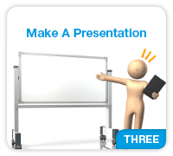

1. Button and title page for Introduction to make a presentation (150x135)

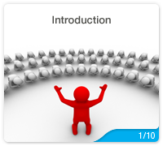

1. Button & Title Page for the topic 1– Prepare a Presentation (150x135)

 

1. Button & Title Page for the topic 2 – Deliver a Presentation (150x135)

 

1. Button & Title Page for the topic 3 – Review the presentation (150x135)

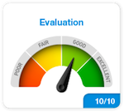 

1. Button & Icon for Workplace Assessment Submission (150x135) & (200x180)



 



1. Button for Download Workplace Assessment 1 (150x135)

 

1. Button for Download Workplace Assessment 2 (150x135)

 

1. Button & Icon for Knowledge Evidence Check Submission (150x135)



1. Icon for Assessment instructions



1. Icon for Proteus HUB

