

**Identify Risk and**

**Apply Risk Management Processes**

Unit of Competency – BSBRSK401

Performance Evidence

**Workplace Assessment 1 of 1**

**Risk Management Plan**

**In the Workplace:**

To complete this assessment you will need to complete a Risk Management Plan for your team. You will need to identify risks, analyse and evaluate these risks, treat these risks and then monitor and review the effectiveness of the risk treatment.

Once you have completed the Risk Management Plan you will need to meet with your Manager to discuss the plan and arrange sign off.

**There are 4 Parts to this assessment**.

Part 1 is to be completed after finishing Topic 1 “Identify Risks”,

Part 2 is to be completed after finishing Topic 2 “Analyse and Evaluate Risks”,

Part 3 is to be completed after finishing Topic 3 “Treat risks”,

Part 4 is to be completed after finishing Topic 4 “Monitor and review effectiveness of risk treatment/s”.

**Part 1 – Identify Risks**

**ASSESSMENT INSTRUCTIONS**

You should have now read the content and completed the short answer questions for the first topic *‘Identify Risks’.*

**Step 1**

At this point, please go to page 7 of this workbook and identify and record 3 risks for each category.

*Please note, you are not required to analyse and evaluate the risks and complete the 3 right hand columns, until you have completed Topic 2 (Analyse and Evaluate Risks) of this Unit.*

**Risk Management Plan**

**For My Department**

**Department:**

**Categories of Risk**

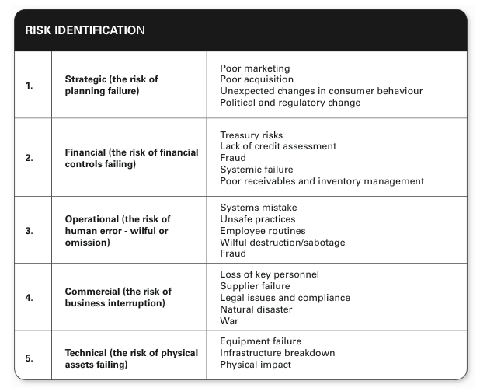

**Evaluating Risk**

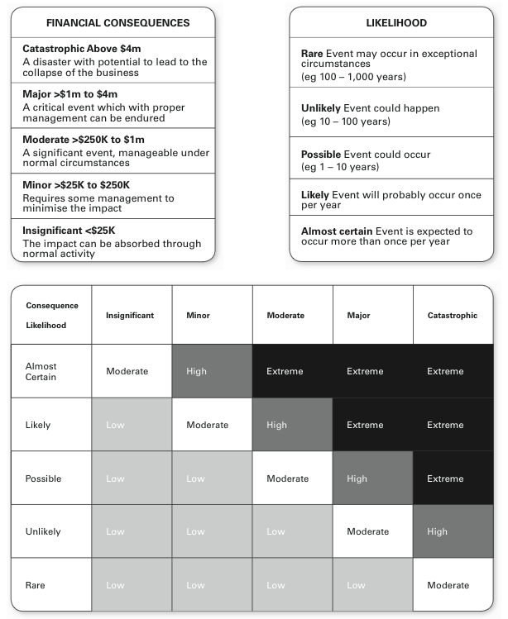

**Risk Management Plan |Risk Identification**  
  
In the table below Identify 3 risks for each category. Once you have completed this, go back online to Topic 2 *‘Analyse and Evaluate risks’*.  *You are not required to complete the 3 right hand columns until you have completed Topic 2 online.*

|  |  |  |  |  |
| --- | --- | --- | --- | --- |
| **Risk Identification** | | | | |
| **Type** | **Risks** | **Likelihood** | **Consequence** | **Grade** |
| *eg. Technical* | *Production machinery has  a major malfunction* | *Unlikely* | *Major* | *Major* |
| 1.  Strategic |  |  |  |  |
|  |  |  |  |
|  |  |  |  |
| 2. Financial |  |  |  |  |
|  |  |  |  |
|  |  |  |  |
| 3.  Operational |  |  |  |  |
|  |  |  |  |
|  |  |  |  |
| 4. Employee |  |  |  |  |
|  |  |  |  |
|  |  |  |  |
| 5. Environmental |  |  |  |  |
|  |  |  |  |
|  |  |  |  |
| 6.  Political and Economic |  |  |  |  |
|  |  |  |  |
|  |  |  |  |
| 7. Health and Safety |  |  |  |  |
|  |  |  |  |
|  |  |  |  |

**Part 2 – Analyse and Evaluate Risks**

**ASSESSMENT INSTRUCTIONS**

You should have now read the content and completed the short answer questions for the second topic *‘Analyse and Evaluate risks’.*

**Step 1**

At this point, please go back to page 7 of this workbook and complete the template by analysing and evaluating the risks you identified previously. The chart on page 6 will assist you with this. When doing this you should consult with relevant stakeholders within your organization, to gain their input.

Once you have completed Identifying, Analysing and Evaluating your risks on page 7, please go back online and continue with Topic 3 – *‘Treat Risks’.*

**Part 3 – Treat Risks**

**ASSESSMENT INSTRUCTIONS**

You should have now read the content and completed the short answer questions for the third topic *‘Treat Risks’.*

**Step 1**

Please now select 1 risk from each risk category and decide on the risk management approach you will take to reduce or mitigate this risk. Please record this by completing page 10 of this workbook.

**Step 2**

Now that you have a risk management approach for each risk, you will need to support your organization by writing a policy or procedure for others in the organization to follow. Please complete these on page 11 of this workbook using the example provided.

**Step 3**

Please now consider risks that have been identified that are beyond your own area of responsibility. On page 12 please identify the other areas of your organization that are affected and what risks and how you will be referring to them.

**Risk Management Plan | Risk Management Approach**

**Decide on a risk management approach, implement and evaluate**  
(Identify 1 risk from each type and identify the action you will take)

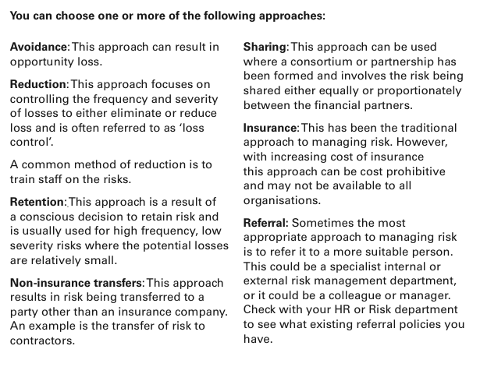

|  |  |  |  |
| --- | --- | --- | --- |
| **Risk Management** | | | |
| **Type** | **Risks** | **Action** |  |
| *eg. Technical* | *Production machinery has a major malfunction* | *A combination of Reduction Approach through Training on best practice of using machine and Non-Insurance Transfers by having regular maintenance performed by a 3rd party who then must supply back up procedures.* | **Implement When?** |
| *Begin training before purchasing machinery* |
| **Evaluate When?** |
| *Every 3 months* |
| 1.  Strategic |  |  | **Implement When?** |
|  |
| **Evaluate When?** |
|  |
| 2. Financial |  |  | **Implement When?** |
|  |
| **Evaluate When?** |
|  |
| 3.  Operational |  |  | **Implement When?** |
|  |
| **Evaluate When?** |
|  |
| 4. Employee |  |  | **Implement When?** |
|  |
| **Evaluate When?** |
|  |
| 5.  Environmental |  |  | **Implement When?** |
|  |
| **Evaluate When?** |
|  |
| 6. Political & Economic |  |  | **Implement When?** |
|  |
| **Evaluate When?** |
|  |
| 7. Health and Safety |  |  | **Implement When?** |
|  |
| **Evaluate When?** |
|  |

**Risk Management Plan | Policy And Procedure**

|  |  |  |
| --- | --- | --- |
| **Risk Policy Procedures** | | |
| **Type** | **Risks** | **Policy and Procedure (rules)** |
| *eg. Technical* | *Production machinery has a major malfunction* | *- staff must complete online training course on machine before using*  *- 3rd party maintenance must be arranged every 2 months* |
|
|
|
| 1.  Strategic |  |  |
|
|
|
| 2. Financial |  |  |
|
|
|
| 3.  Operational |  |  |
|
|
|
| 4. Employee |  |  |
|
|
|
| 5.  Environmental |  |  |
|
|
|
| 6. Political and Economic |  |  |
|
|
|
| 7. Health and Safety |  |  |
|
|
|

**Risk Management Plan | Evaluation**

**Do any of your risk management approaches increase potential risks in other parts of the organisation or operations? How will you refer this information to them? (min 200 words)**

Your Response:

**Part 4 – Monitor and review effectiveness of risk treatment/s.**

**ASSESSMENT INSTRUCTIONS**

You should have now read the content and completed the short answer questions for the fourth topic *‘Monitor and review effectiveness of risk treatment/s’.*

**Step 1**

The final part of this assessment is to meet with your manager to discuss your completed Risk Management Plan and obtain sign off for this Unit. The Managers Sign Off sheet is on page 14.

Please note, if you are unable to meet with your manager, there are 3 other options available for sign off:

1. Attend a Proteus Implementation Day to be assessed by a Proteus Coach (ph: 1300 219 903 for further information).
2. Arrange an appointment at a Proteus office to be assessed by a Proteus Coach (ph: 1300 219 903)
3. Arrange an appointment for a phone meeting assessment with your Proteus Coach (ph: 1300 219 903)

**Manager’s Sign Off**

|  |  |  |
| --- | --- | --- |
| **Identify risk and apply risk management processes – Workplace Assessment 1** | **Yes** | **No** |
| Did the student consult with relevant stakeholders to identify, analyse and evaluate risks? |  |  |
| Has the student developed and implemented risk treatment plans for their own work area or responsibility? |  |  |
| Has the student referred risks that are beyond their own area of responsibility? |  |  |
| Has the student maintained risk management documentation as part of this assessment? |  |  |
| **Feedback – Skills Performance** |  |  |
| What feedback can you give you the staff member regarding the standard of their performance in these skills listed above? (50-100 words). Please consider areas of success and areas of development. | | |
| **Your Feedback:** | | |

**Your Name:**

**Your Job Title:**

**Your Signature: _____________________**

**Date:**

**ASSESSMENT INSTRUCTIONS**

This is the end of Workplace Assessment 1.

Please now go online to the topic menu for ‘Unit 11 - Identify risk and apply risk management processes’ and click on the box **‘Workplace Assessment’** to submit Workplace Assessment 1.

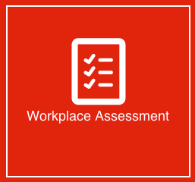

**Grading and Feedback.**

Feedback will be provided for each question through the Online Learning System. You will receive an email notification of feedback being posted.

If there are any required changes you will be given an opportunity to resubmit.

Proteus Leadership – 1300 219 903 – [online@proteusleadership.com](mailto:online@proteusleadership.com)

-- End of Document --