

**Unit 8: Develop & Manage Performance Management Processes**

Unit of Competency – BSBHRM512

Knowledge Evidence

**Knowledge Assessment**

**ASSESSMENT INSTRUCTIONS**

For this task you must research each of the following topics, and then answer the following questions. The research topics are:

1. List characteristics of a learning organisation
2. Outline policies and legislation relevant to performance management
3. Summarise grievance procedures
4. Explain models for giving feedback and options for skill development
5. Describe options in the design of performance management processes
6. Outline role of performance management in relation to broader human resources and business objectives

**ASSESSMENT INSTRUCTIONS**

This is the end of the Knowledge Assessment.

Please now go online to the topic menu for ‘Unit 8 – Develop and manage performance management processes’ and click on the box **‘Knowledge Evidence** to submit your Knowledge Assessment.

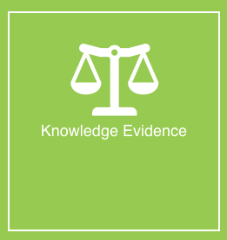

**Grading and Feedback.**

Feedback will be provided for each question through the Online Learning System. You will receive an email notification of feedback being posted.

If there are any required changes you will be given an opportunity to resubmit.

Proteus Leadership – 1300 219 903 – [online@proteusleadership.com](mailto:online@proteusleadership.com)

-- End of Document --