

**Unit 4: Lead and Manage Effective Workplace Relationships**

Unit of Competency – BSBLDR502

Knowledge Evidence

**Knowledge Assessment**

**ASSESSMENT INSTRUCTIONS**

For this task you must research each of the following topics, and then answer the following questions. The research topics are:

1. Explain how your organisations systems, policies and procedures supports the development of effective work relationships focusing on interpersonal styles, communications, consultation, cultural and social sensitivity, networking and conflict resolution. Please provide at least 2 examples.
2. Outline legislation relevant to managing effective workplace relationships.

**ASSESSMENT INSTRUCTIONS**

This is the end of the Knowledge Assessment.

Please now go online to the topic menu for ‘Unit 4 – Lead and manage effective workplace relationships’ and click on the box **‘Knowledge Evidence** to submit your Knowledge Assessment.

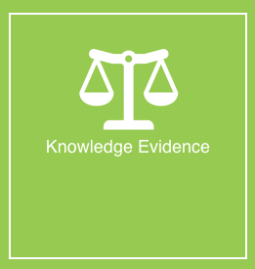

**Grading and Feedback.**

Feedback will be provided for each question through the Online Learning System. You will receive an email notification of feedback being posted.

If there are any required changes you will be given an opportunity to resubmit.

Proteus Leadership – 1300 219 903 – [online@proteusleadership.com](mailto:online@proteusleadership.com)

-- End of Document --