

**Unit 4: Lead and Manage Effective Workplace Relationships**

Unit of Competency – BSBLDR502

Performance Evidence

**Workplace Assessment**

**There are 4 Parts to this assessment**.

Part 1 is to be completed after finishing Topic 1 “Manage ideas and information

Part 2 is to be completed after finishing Topic 2 “Establish systems to develop trust and confidence”,

Part 3 is to be completed after finishing Topic 3 “Manage the development and maintenance of networks and relationships”,

Part 4 is to be completed after finishing Topic 4 “Manage difficulties to achieve positive outcome”.

**Part 1 – Managing Ideas & Information**

**ASSESSMENT INSTRUCTIONS**

You should have now read the content and completed the short answer questions for the first topic *‘*Manage ideas and information’*.*

In the space below, answer the following questions:

**Question 1**

How might you communicate information to support your team to achieve their work responsibilities? (100 words)

**Your Response:**

**Question 2**

How will you ensure employees have the opportunity to contribute to issues related to their performance? (100 words)

**Your Response:**

**Question 3**

How will you ensure issues raise by staff are resolved promptly? (100 words)

**Your Response:**

*Please return online and continue with Topic 2 –* Establish systems to develop trust and confidence*.*

*----*

**Part 2 – Developing Trust & Confidence**

**ASSESSMENT INSTRUCTIONS**

You should have now read the content and completed the short answer questions for the second topic *‘*Establish systems to develop trust and confidence’*.*

In this Part, you are required to locate you internal policy on ‘Cultural Diversity and Ethical Values’ and paste it in the space below (or attached it to your submission). If you don’t have an internal policy for this then please create one in the space below:

**Policy:**

**Question 1**

How will you ensure the team will adhere to this policy?

**Your Response:**

**Question 2**

How will you ensure your behavior and professional conduct promotes trust within your team? (100 words)

**Your Response:**

**Question 3**

How could you adjust your behavioural style to meet the organisations cultural diversity and ethical environment? (100 words)

**Your Response:**

# 

*Please return online and continue with Topic 3 –* Manage the development and maintenance of networks and relationships*.*

*----*

**Part 3 – Manage the development and maintenance of networks and relationships**

**ASSESSMENT INSTRUCTIONS**

You should have now read the content and completed the short answer questions for the third topic *‘*Manage the development and maintenance of networks and relationships’*.*

In this Part, you are required to complete steps 1 and 2.

**Step 1 – Behavioural Styles**

Utilising the Behavioural Styles model plot the following people and identify which style they are:

* A Difficult Worker/Colleague
* Your Manager/Team Leader
* Partner/Close Friend

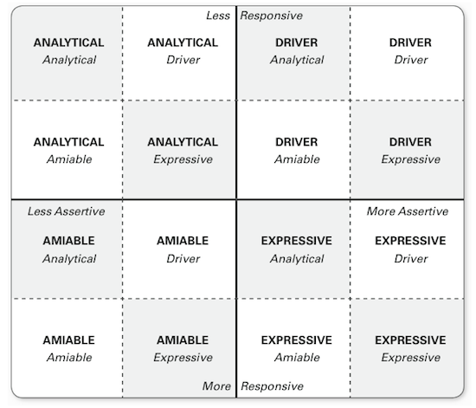

**Question 1**

In the space below write their name, style and two things you could do to improve your relationship.

**Your Response:**

# 

**Step 2 – Plan to Create a Positive Workplace Culture**

**Question 2**

Identify the main steps you would take to assist in creating a more positive workplace culture within your organisation? (300 words)

**Your Response:**

**Question 3**

What objections and barriers you may encounter and identify strategies for dealing with them? (300 words)

**Your Response:**

**Question 4**

What is your involvement in the process and then identify your strategies for gaining co-operation from staff and management? (300 words)

**Your Response:**

*Please return online and continue with Topic 4 –* Manage difficulties to achieve positive outcome*.*

*----*

**Part 4 –Difficulties into Positive Outcomes**

**ASSESSMENT INSTRUCTIONS**

You should have now read the content and completed the short answer questions for the fourth topic *‘*Manage difficulties to achieve positive outcome’*.*

In this part you are required to complete Steps 1 and 2.

**Step 1 – Strategies for Resolving Conflict**

Using the checklists on the following pages develop strategies for resolving conflict with each behavioural style.

|  |  |
| --- | --- |
| **Style** | **Strategies for Resolving Conflict** |
| **Analytical** |  |
| **Driver** |  |
| **Amiable** |  |
| **Expressive** |  |

**Checklist For Role Shifting With “Drivers”**

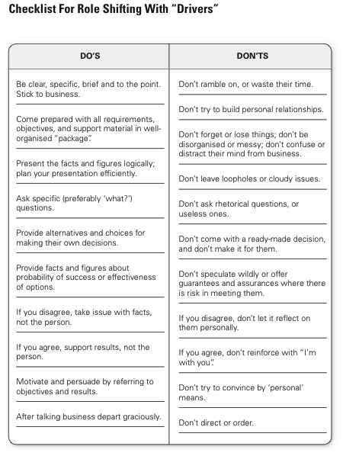**Checklist For Role Shifting With “Expressives”**

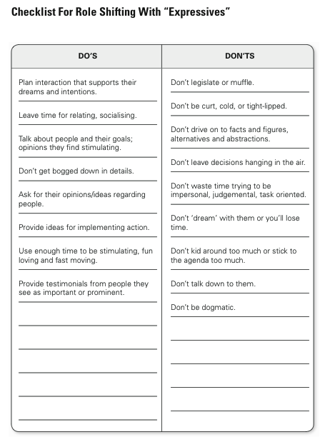**Checklist For Role Shifting With “Amiables”**

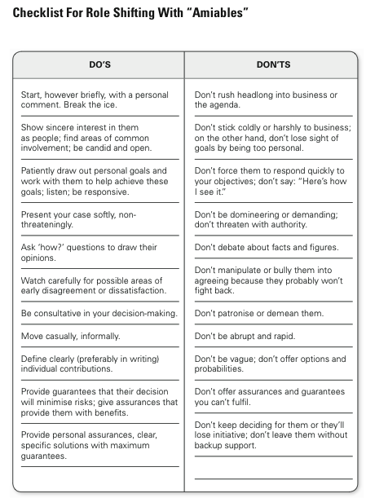**Checklist For Role Shifting With “Analyticals”**

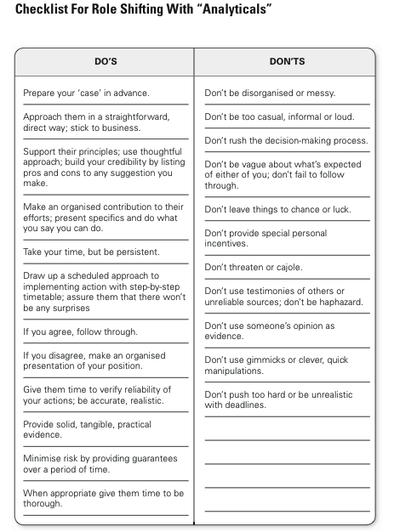

**Step 2 - Manager’s Sign Off**

Once you have completed all the above meet with your manager to gain feedback and get sign off for this Unit. *Please note, your manager must provide written feedback in the space below*

If you are unable to meet with your manager there are 2 other options available for sign off:

1. Attend a Proteus Implementation Day
2. Arrange an appointment with your Proteus Coach

|  |  |  |
| --- | --- | --- |
| **Lead & Manage Effective Workplace Relationships – Workplace Assessment** | **Yes** | **No** |
| Did the student develop and/or implement processes to manage ideas and information including:   * communicating information to support others to achieve work responsibilities * facilitating employees' contributions to consultation on work issues * providing feedback on the outcomes of consultations * resolution of issues raised or referral to relevant personnel ? |  |  |
| Did the student establish and/or implement policies to ensure that the organisation’s cultural diversity and ethical values are adhered to? |  |  |
| Did the student provide leadership through own behaviour including:   * professional conduct that promotes trust with internal and external contacts * adjusting own interpersonal communication style to meet the organisation’s cultural diversity and ethical environment? |  |  |
| Did the student plan for, and manage, the use of networks to support identifiable outcomes for the team and the organisation? |  |  |
| Did the student develop and/or implement processes and systems to manage difficulties including:   * identifying and resolving conflicts and other difficulties according to organisational policies and procedures * planning how to address difficulties * providing guidance, counselling and support to assist co-workers in resolving their work difficulties? |  |  |
| **Feedback – Skills Performance** |  |  |
| What feedback can you give you the staff member regarding the standard of their performance in these skills listed above? (50-100 words). Please consider areas of success and areas of development. | | |

**Managers Name:**

**Managers Job Title:**

**Managers Signature: _____________________**

**Date:**

**ASSESSMENT INSTRUCTIONS**

This is the end of the Workplace Assessment.

Please now go online to the topic menu for ‘Unit 4 – Lead and manage effective workplace relationships’ and click on the box **‘Workplace Assessment’** to submit your Workplace Assessment.

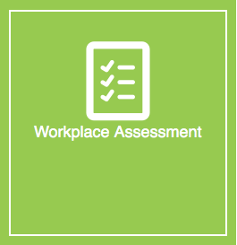

**Grading and Feedback.**

Feedback will be provided for each question through the Online Learning System. You will receive an email notification of feedback being posted.

If there are any required changes you will be given an opportunity to resubmit.

Proteus Leadership – 1300 219 903 – [online@proteusleadership.com](mailto:online@proteusleadership.com)

-- End of Document --