

**Unit 1: Communicate With Influence**

Unit of Competency – BSBLDR503

Knowledge Evidence

**Knowledge Assessment**

**ASSESSMENT INSTRUCTIONS**

For this task you must research each of the following topics, and then answer the following questions. The research topics are:

1. Explain the business and organisational protocols for the release of information and communicating internally or externally
2. Explain the requirements to maintain confidentiality in the workplace
3. Identify industry, media and government organisations, events and communication channels relevant to the organisation
4. Demonstrate principles of cross-cultural communication
5. Explain principles of negotiation, mediation, conflict resolution and incident de-escalation
6. Describe structured and inclusive meeting procedures

**ASSESSMENT INSTRUCTIONS**

This is the end of the Knowledge Assessment.

Please now go online to the topic menu for ‘Unit 1 – Communicate with influence’ and click on the box **‘Knowledge Evidence** to submit your Knowledge Assessment.

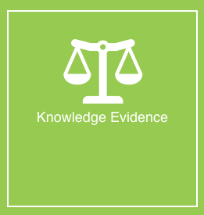

**Grading and Feedback.**

Feedback will be provided for each question through the Online Learning System. You will receive an email notification of feedback being posted.

If there are any required changes you will be given an opportunity to resubmit.

Proteus Leadership – 1300 219 903 – [online@proteusleadership.com](mailto:online@proteusleadership.com)

-- End of Document --