

**Unit 5: Manage People Performance**

Unit of Competency – BSBMGT502

Knowledge Evidence

**Knowledge Assessment**

**ASSESSMENT INSTRUCTIONS**

For this task you must research each of the following topics, and then answer the following questions. The research topics are:

1. Outline relevant legislative and regulatory requirements for managing performance
2. Outline relevant awards and certified agreements
3. Explain performance measurement systems utilised within the organisation
4. Explain unlawful dismissal rules and due process
5. Describe staff development options and information

**ASSESSMENT INSTRUCTIONS**

This is the end of the Knowledge Assessment.

Please now go online to the topic menu for ‘Unit 5 – Manage People Performance’ click on the box **‘knowledge Evidence** to submit your Knowledge Assessment.

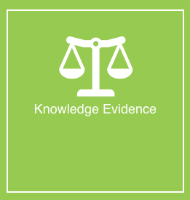

**Grading and Feedback.**

Feedback will be provided for each question through the Online Learning System. You will receive an email notification of feedback being posted.

If there are any required changes you will be given an opportunity to resubmit.

Proteus Leadership – 1300 219 903 – [online@proteusleadership.com](mailto:online@proteusleadership.com)

-- End of Document --