

**Unit 10: Facilitate Continuous Improvement**

Unit of Competency – BSBMGT516

Knowledge Evidence

**Knowledge Assessment**

**ASSESSMENT INSTRUCTIONS**

For this task you must research each of the following topics, and then answer the following questions. The research topics are:

1. Explain how systems and procedures can support effective continuous improvement
2. Explain how continuous improvement systems and processes relate to other business systems and requirements including, knowledge management, quality, performance management and sustainability

**ASSESSMENT INSTRUCTIONS**

This is the end of the Knowledge Assessment.

Please now go online to the topic menu for ‘Unit 10 – Facilitate continuous improvement’ and click on the box **‘Knowledge Evidence** to submit your Knowledge Assessment.

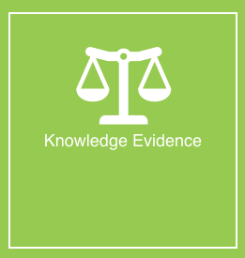

**Grading and Feedback.**

Feedback will be provided for each question through the Online Learning System. You will receive an email notification of feedback being posted.

If there are any required changes you will be given an opportunity to resubmit.

Proteus Leadership – 1300 219 903 – [online@proteusleadership.com](mailto:online@proteusleadership.com)

-- End of Document --