

**Unit 6: Manage Operational Plan**

Unit of Competency – BSBMGT517

Knowledge Evidence

**Knowledge Assessment**

**ASSESSMENT INSTRUCTIONS**

For this task you must research each of the following topics, and then answer the following questions. The research topics are:

1. Describe models and methods for operational plans
2. Explain the role of an operational plan in achieving the organisation’s objectives
3. Explain budgeting processes
4. List alternative approaches to developing key performance indicators to meet business objectives
5. Outline the legislative and regulatory context relevant to the operational plan of the organisation
6. Outline your organisation’s policies, practices and procedures that directly relate to the operational plan

**ASSESSMENT INSTRUCTIONS**

This is the end of the Knowledge Assessment.

Please now go online to the topic menu for ‘Unit 6 – Manage Operational Plan’ and click on the box **‘Knowledge Evidence** to submit your Knowledge Assessment.

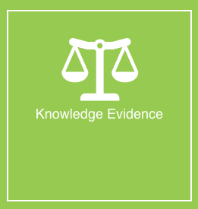

**Grading and Feedback.**

Feedback will be provided for each question through the Online Learning System. You will receive an email notification of feedback being posted.

If there are any required changes you will be given an opportunity to resubmit.

Proteus Leadership – 1300 219 903 – [online@proteusleadership.com](mailto:online@proteusleadership.com)

-- End of Document --