

**Unit 11: Undertake Project Work**

Unit of Competency – BSBPMG522

Knowledge Evidence

**Knowledge Assessment**

**ASSESSMENT INSTRUCTIONS**

For this task you must research each of the following topics, and then answer the following questions. The research topics are:

1. Give examples of project management tools and how they contribute to a project
2. Outline types of documents and other sources of information commonly used in defining the parameters of a project
3. Explain processes for identifying and managing risk in a project
4. Outline the organisation’s mission, goals, objectives and operations and how the project relates to them
5. Explain the organisation's procedures and processes that are relevant to managing a project including:
   1. Lines of authority and approvals
   2. Quality assurance
   3. Human resources
   4. Budgets and finance
   5. Recordkeeping
   6. Reporting
6. Outline the legislative and regulatory context of your organisation in relation to project work, including work health and safety (WHS) requirements

**ASSESSMENT INSTRUCTIONS**

This is the end of the Knowledge Assessment.

Please now go online to the topic menu for ‘Unit 11 – Undertake Project Work’ and click on the box **‘Knowledge Evidence’** to submit your Knowledge Assessment.

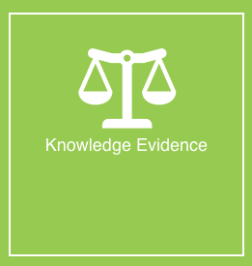

**Grading and Feedback.**

Feedback will be provided for each question through the Online Learning System. You will receive an email notification of feedback being posted.

If there are any required changes you will be given an opportunity to resubmit.

Proteus Leadership – 1300 219 903 – [online@proteusleadership.com](mailto:online@proteusleadership.com)

-- End of Document --