

**Manage Risk**

Unit of Competency – BSBRSK501

Performance Evidence

**Workplace Assessment**

**There are 4 Parts to this assessment**.

Part 1 is to be completed after finishing Topic 1 “Establish risk context”,

Part 2 is to be completed after finishing Topic 2 “Identify risks”,

Part 3 is to be completed after finishing Topic 3 “Analyse risks”,

Part 4 is to be completed after finishing Topic 4 “Select and implement treatments”.

**Part 1 – Risk Context**

**ASSESSMENT INSTRUCTIONS**

You should have now read the content and completed the short answer questions for the first topic *‘*Establish risk context’*.*

**Activity 1:**

Risks can generally be divided up into the 5 different categories below.

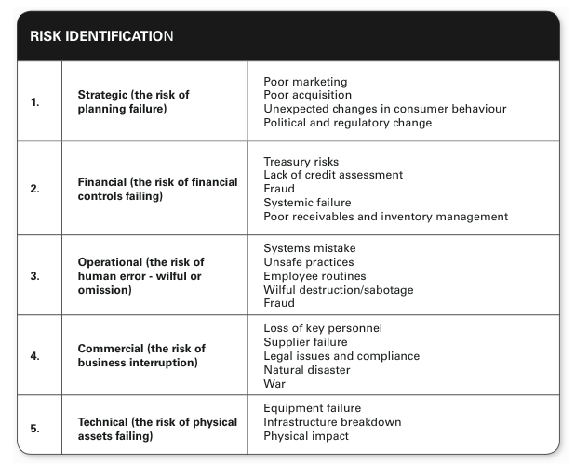

**Part 2 – Risk Identification**

**ASSESSMENT INSTRUCTIONS**

You should have now read the content and completed the short answer questions for the second topic *‘*Identify risks’*.*

**Activity:**

In the following table, identify 3 risks for each of the risk categories:

*[Please note: At this stage you do not need to complete the likelihood, consequence and grade column]*

|  |  |  |  |  |
| --- | --- | --- | --- | --- |
| **Risk Identification** | | | | |
| **Type** | **Risks** | **Likelihood** | **Consequence** | **Grade** |
| *eg. Technical* | *Production machinery has  a major malfunction* | *Unlikely* | *Major* | *Major* |
| 1.  Strategic |  |  |  |  |
|  |  |  |  |
|  |  |  |  |
| 2. Financial |  |  |  |  |
|  |  |  |  |
|  |  |  |  |
| 3.  Operational |  |  |  |  |
|  |  |  |  |
|  |  |  |  |
| 4. Employee |  |  |  |  |
|  |  |  |  |
|  |  |  |  |
| 5. Environmental |  |  |  |  |
|  |  |  |  |
|  |  |  |  |
| 6.  Political and Economic |  |  |  |  |
|  |  |  |  |
|  |  |  |  |
| 7. Health and Safety |  |  |  |  |
|  |  |  |  |
|  |  |  |  |

**Part 3 – Risk Evaluation**

**ASSESSMENT INSTRUCTIONS**

You should have now read the content and completed the short answer questions for the third topic *‘*Analyse risks’*.*

**Activity:**

Using the risk evaluation table and definitions below. Please return to page 4 and complete the likelihood, consequence and grade columns.

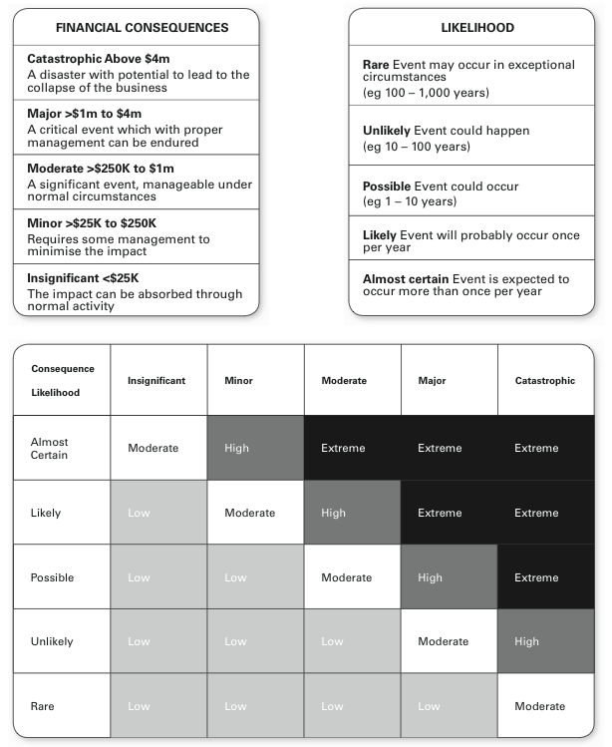

**Part 4 – Risk Management Approaches**

**ASSESSMENT INSTRUCTIONS**

You should have now read the content and completed the short answer questions for the fourth topic *‘*Select and implement treatments’*.*

**Activity:**

Now that you have graded your risk. Choose a risk from each category and using the information below complete the risk approach table on page 7.

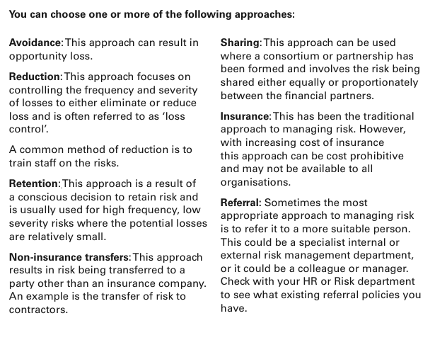

|  |  |  |  |
| --- | --- | --- | --- |
| **Risk Management Approaches** | | | |
| **Type** | **Risks** | **Action** |  |
| *eg. Technical* | *Production machinery has a major malfunction* | *A combination of Reduction Approach through Training on best practice of using machine and Non-Insurance Transfers by having regular maintenance performed by a 3rd party who then must supply back up procedures.* | **Implement When?** |
| *Begin training before purchasing machinery* |
| **Evaluate When?** |
| *Every 3 months* |
| 1.  Strategic |  |  | **Implement When?** |
|  |
| **Evaluate When?** |
|  |
| 2. Financial |  |  | **Implement When?** |
|  |
| **Evaluate When?** |
|  |
| 3.  Operational |  |  | **Implement When?** |
|  |
| **Evaluate When?** |
|  |
| 4. Employee |  |  | **Implement When?** |
|  |
| **Evaluate When?** |
|  |
| 5.  Environmental |  |  | **Implement When?** |
|  |
| **Evaluate When?** |
|  |
| 6. Political & Economic |  |  | **Implement When?** |
|  |
| **Evaluate When?** |
|  |
| 7. Health and Safety |  |  | **Implement When?** |
|  |
| **Evaluate When?** |
|  |

**Risk Management Plan | Stakeholders**

How will you communicate your risk findings and actions to all stakeholders?

|  |  |  |
| --- | --- | --- |
| **Stakeholder** | **How can  they help  identify/analyse risks?** | **What & how will you  communicate  to them?** |
|  |  |  |
|  |  |  |
|  |  |  |

**Risk Management Plan | Evaluation**

**Do any of your risk management approaches increase potential risks in other parts of the organisation or operations? (min 200 words)**

**Manager’s Sign Off**

|  |  |  |
| --- | --- | --- |
| **Manage Risk – Workplace Assessment** | **Yes** | **No** |
| Did the student analyse information from a range of sources to identify the scope and context of the risk management process including:   * stakeholder analysis * political, economic, social, legal, technological and policy context * current arrangements * objectives and critical success factors for the area included in scope * risks that may apply to scope ? |  |  |
| Did the student consult and communicate with relevant stakeholders to identify and assess risks, determine appropriate risk treatment actions and priorities and explain the risk management processes? |  |  |
| Did the student develop and implement an action plan to treat risks? |  |  |
| Did the student monitor and evaluate the action plan and risk management process? |  |  |
| Did the student maintain documentation? |  |  |
| **Feedback – Skills Performance** |  |  |
| What feedback can you give you the staff member regarding the standard of their performance in these skills listed above? (50-100 words). Please consider areas of success and areas of development. |  |  |
| **Your Feedback:** |  |  |

**Your Name:**

**Your Job Title:**

**Your Signature: _____________________**

**Date:**

**ASSESSMENT INSTRUCTIONS**

This is the end of the Workplace Assessment.

Please now go online to the topic menu for ‘Unit 12 – Manage Risk’ and click on the box **‘Workplace Assessment’** to submit your Workplace Assessment.

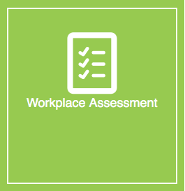

**Grading and Feedback.**

Feedback will be provided for each question through the Online Learning System. You will receive an email notification of feedback being posted.

If there are any required changes you will be given an opportunity to resubmit.

Proteus Leadership – 1300 219 903 – [online@proteusleadership.com](mailto:online@proteusleadership.com)

-- End of Document --