

**Unit 12: Manage Risk**

Unit of Competency – BSBRSK501

Knowledge Evidence

**Knowledge Assessment**

**ASSESSMENT INSTRUCTIONS**

For this task you must research each of the following topics, and then answer the following questions. The research topics are:

1. Outline the purpose and key elements of current risk management standards
2. Outline the legislative and regulatory context of your organisation in relation to risk management
3. Outline organisational policies, procedures and processes for risk management

**ASSESSMENT INSTRUCTIONS**

This is the end of the Knowledge Assessment.

Please now go online to the topic menu for ‘Unit 12 – Manage Risk’ and click on the box **‘Knowledge Evidence’** to submit your Knowledge Assessment.

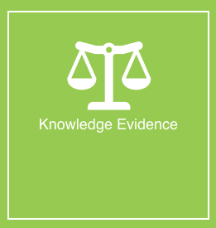

**Grading and Feedback.**

Feedback will be provided for each question through the Online Learning System. You will receive an email notification of feedback being posted.

If there are any required changes you will be given an opportunity to resubmit.

Proteus Leadership – 1300 219 903 – [online@proteusleadership.com](mailto:online@proteusleadership.com)

-- End of Document --