

**Unit 12: Manage Risk**

Unit of Competency – BSBRSK501

Performance Evidence

**Workplace Assessment**

**There are 4 Parts to this assessment**.

Part 1 is to be completed after finishing Topic 1 “Establish risk context”,

Part 2 is to be completed after finishing Topic 2 “Identify risks”,

Part 3 is to be completed after finishing Topic 3 “Analyse risks”,

Part 4 is to be completed after finishing Topic 4 “Select and implement treatments”.

**Part 1 – Establish Risk Context**

**ASSESSMENT INSTRUCTIONS**

You should have now read the content and completed the short answer questions for the first topic *‘*Establish risk context’*.*

**Question 1**

List some reasons why it is important to have a risk management plan?

**Your Response:**

**Question 2**

What risk management arrangements do you currently have in your organisation?

**Your Response:**

**Question 3**

What are some strengths and weaknesses of these current arrangements?

**Your Response:**

**Question 4**

Who are the stakeholders who may be affected by the risks experiences by you and your immediate team?

**Your Response:**

*Please return online and continue with Topic 2 –* Identify risks’*.*

*----*

**Part 2 – Risk Identification**

**ASSESSMENT INSTRUCTIONS**

You should have now read the content and completed the short answer questions for the second topic *‘*Identify risks’*.*

In the following table, identify 3 risks for each of the risk categories. Please consult your team and/ or your manager to assist you with this process.

***[Please note: At this stage you do not need to complete the likelihood, consequence and grade columns]***

|  |  |  |  |  |
| --- | --- | --- | --- | --- |
| **Risk Identification** | | | | |
| **Type** | **Risks** | **Likelihood** | **Consequence** | **Grade** |
| *eg. Technical* | *Production machinery has  a major malfunction* | *Unlikely* | *Major* | *Major* |
| 1.  Strategic |  |  |  |  |
|  |  |  |  |
|  |  |  |  |
| 2. Financial |  |  |  |  |
|  |  |  |  |
|  |  |  |  |
| 3.  Operational |  |  |  |  |
|  |  |  |  |
|  |  |  |  |
| 4. Employee |  |  |  |  |
|  |  |  |  |
|  |  |  |  |
| 5. Health and Safety |  |  |  |  |
|  |  |  |  |
|  |  |  |  |
| 6.  Political |  |  |  |  |
|  |  |  |  |
|  |  |  |  |
| 7. Economic |  |  |  |  |
|  |  |  |  |
|  |  |  |  |
| 8. Social |  |  |  |  |
|  |  |  |  |
|  |  |  |  |
| 9. Technological |  |  |  |  |
|  |  |  |  |
|  |  |  |  |
| 10. Environmental |  |  |  |  |
|  |  |  |  |
|  |  |  |  |
| 11. Legal |  |  |  |  |
|  |  |  |  |
|  |  |  |  |

*Please return online and continue with Topic 3 –* Analyse risks’*.*

*----*

**Part 3 – Risk Evaluation**

**ASSESSMENT INSTRUCTIONS**

You should have now read the content and completed the short answer questions for the third topic *‘*Analyse risks’*.*

Using the risk evaluation table and definitions below. Please return to page 4 and complete the likelihood, consequence and grade columns.

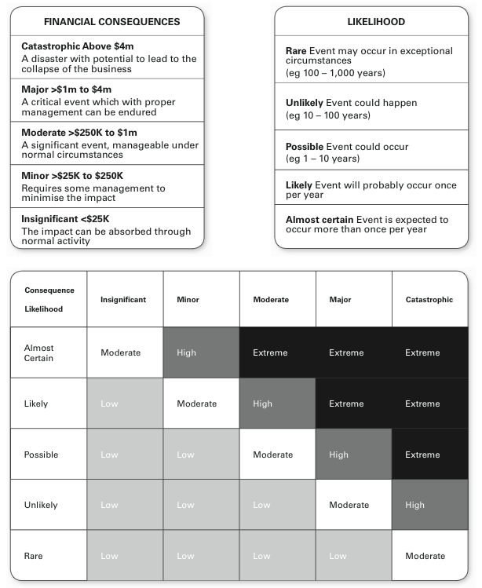

*Please return online and continue with Topic 4 –* Select and implement treatments’*.*

*----*

**Part 4 – Risk Management Approaches**

**ASSESSMENT INSTRUCTIONS**

You should have now read the content and completed the short answer questions for the fourth topic *‘*Select and implement treatments’*.*

In this Part, you are required to complete steps 1-4

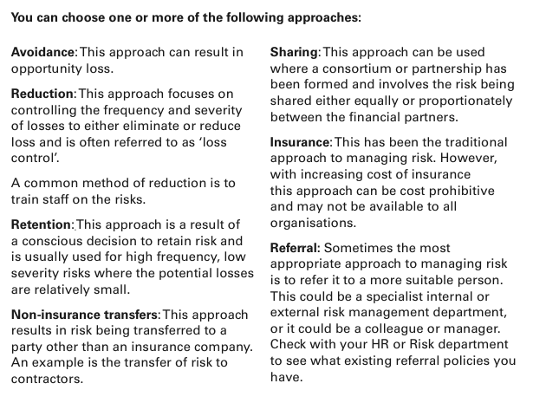

**Step 1 – Risk Approaches**

Now that you have graded the risks, choose 1 risk from each category and using the information on the previous page complete the risk approach table below.

|  |  |  |  |
| --- | --- | --- | --- |
| **Risk Management Approaches** | | | |
| **Type** | **Risks** | **Action** |  |
| *eg. Technical* | *Production machinery has a major malfunction* | *A combination of Reduction Approach through Training on best practice of using machine and Non-Insurance Transfers by having regular maintenance performed by a 3rd party who then must supply back up procedures.* | **Implement When?** |
| *Begin training before purchasing machinery* |
| **Evaluate When?** |
| *Every 3 months* |
| 1.  Strategic |  |  | **Implement When?** |
|  |
| **Evaluate When?** |
|  |
| 2. Financial |  |  | **Implement When?** |
|  |
| **Evaluate When?** |
|  |
| 3.  Operational |  |  | **Implement When?** |
|  |
| **Evaluate When?** |
|  |
| 4. Employee |  |  | **Implement When?** |
|  |
| **Evaluate When?** |
|  |
| 5.  Health and Safety |  |  | **Implement When?** |
|  |
| **Evaluate When?** |
|  |
| 6. Political |  |  | **Implement When?** |
|  |
| **Evaluate When?** |
|  |
| 7. Economic |  |  | **Implement When?** |
|  |
| **Evaluate When?** |
|  |
| 8. Social |  |  | **Implement When?** |
|  |
| **Evaluate When?** |
|  |
| 9.  Technological |  |  | **Implement When?** |
|  |
| **Evaluate When?** |
|  |
| 10. Environmental |  |  | **Implement When?** |
|  |
| **Evaluate When?** |
|  |
| 11. Legal |  |  | **Implement When?** |
|  |
| **Evaluate When?** |
|  |

**Step 2 - Risk Communication**

How will you communicate your risk findings and actions to all stakeholders?

|  |  |  |
| --- | --- | --- |
| **Stakeholder** | **How can  they help  identify/analyse risks?** | **What & how will you  communicate  to them?** |
|  |  |  |
|  |  |  |
|  |  |  |

**Step 3 - Risk Evaluation**

**Question 1**

Do any of your risk management approaches increase potential risks in other parts of the organisation or operations? (min 200 words)

**Your Response:**

**Step 4 - Manager’s Sign Off**

Once you have completed all the above meet with your manager to gain feedback and get sign off for this Unit. *Please note, your manager must provide written feedback in the space below*

If you are unable to meet with your manager there are 2 other options available for sign off:

1. Attend a Proteus Implementation Day
2. Arrange an appointment with your Proteus Coach

|  |  |  |
| --- | --- | --- |
| **Manage Risk – Workplace Assessment** | **Yes** | **No** |
| Did the student analyse information from a range of sources to identify the scope and context of the risk management process including:   * stakeholder analysis * political, economic, social, legal, technological and policy context * current arrangements * objectives and critical success factors for the area included in scope * risks that may apply to scope? |  |  |
| Did the student consult and communicate with relevant stakeholders to identify and assess risks, determine appropriate risk treatment actions and priorities and explain the risk management processes? |  |  |
| Did the student develop and implement an action plan to treat risks? |  |  |
| Did the student monitor and evaluate the action plan and risk management process? |  |  |
| Did the student maintain documentation? |  |  |
| **Feedback – Skills Performance** |  |  |
| What feedback can you give you the staff member regarding the standard of their performance in these skills listed above? (50-100 words). Please consider areas of success and areas of development. | | |

**Managers Name:**

**Managers Job Title:**

**Managers Signature: _____________________**

**Date:**

**ASSESSMENT INSTRUCTIONS**

This is the end of the Workplace Assessment.

Please now go online to the topic menu for ‘Unit 12 – Manage Risk’ and click on the box **‘Workplace Assessment’** to submit your Workplace Assessment.

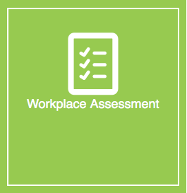

**Grading and Feedback.**

Feedback will be provided for each question through the Online Learning System. You will receive an email notification of feedback being posted.

If there are any required changes you will be given an opportunity to resubmit.

Proteus Leadership – 1300 219 903 – [online@proteusleadership.com](mailto:online@proteusleadership.com)

-- End of Document --