

**Lead and Manage Team Effectiveness**

Unit of Competency – BSBWOR402

Performance Evidence

**Workplace Assessment**

**Leading Team Effectiveness**

**There are 4 Parts to this assessment**.

Part 1 is to be completed after finishing Topic 1 “Establish team performance plan”,

Part 2 is to be completed after finishing Topic 2 “Develop and facilitate team cohesion”,

Part 3 is to be completed after finishing Topic 3 “Facilitate teamwork”,

Part 4 is to be completed after finishing Topic 4 “Liaise with stakeholders”.

**Part 1 –Team Performance**

**ASSESSMENT INSTRUCTIONS**

You should have now read the content and completed the short answer questions for the first topic *‘*Establish team performance plan’*.*

**Activity:**

Using the RARE Teams scale, assess your current team performance status

|  |  |
| --- | --- |
| **RARE Teams** | **Comments** |
| **R**  Results, Results, Results |  |
| **A**  Accountable |  |
| **R**  Robust & Resilient |  |
| **E**  Earned Trust |  |

*Please return online and continue with Topic 2 –* Develop and facilitate team cohesion’*.*

*----*

**Part 2 – Team Cohesion**

**ASSESSMENT INSTRUCTIONS**

You should have now read the content and completed the short answer questions for the second topic *‘*Develop and facilitate team cohesion’*.*

**Activity:**

In the space provided discuss how you would Identify the main steps required to assist in creating a more positive workplace culture within your organization. Consider the objections and barriers you may encounter and identify strategies for dealing with them. Also consider your involvement in the process and then identify your strategies for gaining co-operation from staff and management. (1000 words)

*Please return online and continue with Topic 3 –* Facilitate teamwork*.*

*----*

**Part 3 – Facilitating Team Work**

**ASSESSMENT INSTRUCTIONS**

You should have now read the content and completed the short answer questions for the third topic *‘*Facilitate teamwork’*.*

**Activity:**

Teams can go through different stages and lifecycles. Assess where you team currently stands. What can you do to move some traits and behaviours towards high performance?

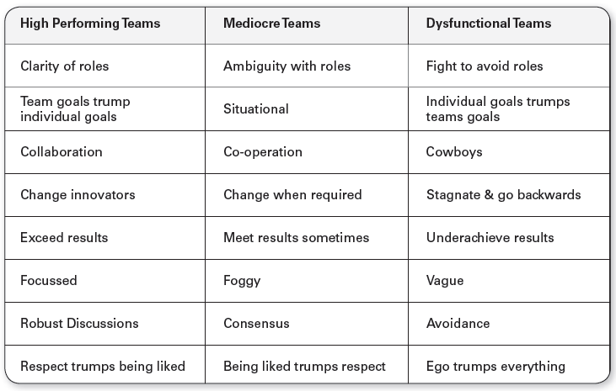

|  |  |
| --- | --- |
| **Current Team Traits and Behaviours** | **Actions to move to high performing team** |
|  |  |

*Please return online and continue with Topic 4 –* Liaise with stakeholders*.*

*----*

**Part 4 – Treating Your Boss as Your Customer**

**ASSESSMENT INSTRUCTIONS**

You should have now read the content and completed the short answer questions for the fourth topic *‘*Liaise with stakeholders’*.*

**Activity:**

List two things under each of the 8 strategies below that you could do to assist you in managing up

|  |  |
| --- | --- |
| **Strategy** | **Actions** |
| Advertise your success |  |
|  |
| Don't over commit |  |
|  |
| Anticipate problems |  |
|  |
| Vary your communication |  |
|  |
| Network outside your company |  |
|  |
| Network within your company |  |
|  |
| Don't complain |  |
|  |
| Celebrate success |  |
|  |

**Manager’s Sign Off**

|  |  |  |
| --- | --- | --- |
| **Lead and Manage Tem Effectiveness – Workplace Assessment** | **Yes** | **No** |
| Did the student use leadership techniques and strategies to facilitate team cohesion and work outcomes including:   * encouraging and fostering shared understanding of purpose, roles and responsibilities * identifying and resolving problems * providing feedback to encourage, value and reward others * modelling desired behaviour and practices |  |  |
| Did the student develop policies and procedures to ensure team members take responsibility for own work and assist others to undertake required roles and responsibilities? |  |  |
| Did the student establish processes to address issues and resolve performance issues? |  |  |
| Did the student support team to meet expected performance outcomes including providing formal and informal learning opportunities as needed? |  |  |
| Did the student develop performance plans with key performance indicators (KPIs), outputs and goals for individuals or the team which incorporate input from stakeholders? |  |  |
| Did the student communicate effectively with a range of stakeholders about team performance plans and team performance? |  |  |
| Did the student facilitate two-way flow of information between team and management relevant to team performance? |  |  |
| Did the student evaluate and take necessary corrective action regarding unresolved issues, concerns and problems raised by internal or external stakeholders? |  |  |
| **Feedback – Skills Performance** |  |  |
| What feedback can you give you the staff member regarding the standard of their performance in these skills listed above? (50-100 words). Please consider areas of success and areas of development. |  |  |
| **Your Feedback:** |  |  |

**Your Name:**

**Your Job Title:**

**Your Signature: _____________________**

**Date:**

**ASSESSMENT INSTRUCTIONS**

This is the end of the Workplace Assessment.

Please now go online to the topic menu for ‘Unit 3 – Lead and Manage Team Effectiveness’ and click on the box **‘Workplace Assessment’** to submit your Workplace Assessment.

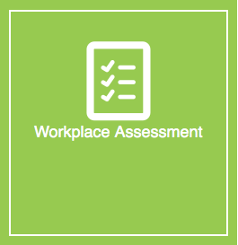

**Grading and Feedback.**

Feedback will be provided for each question through the Online Learning System. You will receive an email notification of feedback being posted.

If there are any required changes you will be given an opportunity to resubmit.

Proteus Leadership – 1300 219 903 – [online@proteusleadership.com](mailto:online@proteusleadership.com)

-- End of Document --