

**Unit 3: Lead and Manage Team Effectiveness**

Unit of Competency – BSBWOR402

Knowledge Evidence

**Knowledge Assessment**

**ASSESSMENT INSTRUCTIONS**

For this task you must research each of the following topics, and then answer the following questions. The research topics are:

1. Explain how group dynamics can support or hinder team performance
2. Outline strategies that can support team cohesion, participation and performance
3. Explain strategies for gaining consensus
4. Explain issue resolution strategies

**ASSESSMENT INSTRUCTIONS**

This is the end of the Knowledge Assessment.

Please now go online to the topic menu for ‘Unit 3 – Lead and Manage Team Effectiveness’ and click on the box **‘Knowledge Evidence’** to submit your Knowledge Assessment.

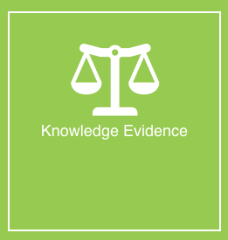

**Grading and Feedback.**

Feedback will be provided for each question through the Online Learning System. You will receive an email notification of feedback being posted.

If there are any required changes you will be given an opportunity to resubmit.

Proteus Leadership – 1300 219 903 – [online@proteusleadership.com](mailto:online@proteusleadership.com)

-- End of Document --