

**Unit 3: Lead and Manage Team Effectiveness**

Unit of Competency – BSBWOR502

Performance Evidence

**Workplace Assessment**

**There are 4 Parts to this assessment**.

Part 1 is to be completed after finishing Topic 1 “Establish team performance plan”,

Part 2 is to be completed after finishing Topic 2 “Develop and facilitate team cohesion”,

Part 3 is to be completed after finishing Topic 3 “Facilitate teamwork”,

Part 4 is to be completed after finishing Topic 4 “Liaise with stakeholders”.

**Part 1 – Establish Team Performance Plan**

**ASSESSMENT INSTRUCTIONS**

You should have now read the content and completed the short answer questions for the first topic *‘*Establish team performance plan’*.*

In this Part, you are required to complete steps 1- 3.

**Step 1 – Vision, Goals and Team Rules**

Take a moment to reflect on what that would look like. You may also like to consult your team and gather their thoughts. In the space below write your new team vision, goals and team rules.

|  |  |
| --- | --- |
| **Vision** |  |
| **Goals** |  |
| **Team rules** |  |

**Step 2 – Purpose, Performance & Passion**

Looking at yourself and your team - list the areas of strength and areas to improve for Purpose, Performance & Passion:

|  |  |  |
| --- | --- | --- |
|  | **Areas of Strength and Areas to Improve** | |
| **Yourself** | **Your Team** |
| 1. **Purpose** |  |  |
| 1. **Performance** |  |  |
| 1. **Passion** |  |  |

**Step 3 – RARE scale**

Using the RARE Teams scale, assess your current team performance status.

|  |  |
| --- | --- |
| **RARE Teams** | **Comments** |
| **R**  Results, Results, Results |  |
| **A**  Accountable |  |
| **R**  Robust & Resilient |  |
| **E**  Earned Trust |  |

*Please return online and continue with Topic 2 –* Develop and facilitate team cohesion’*.*

*----*

**Part 2 – Facilitate Team Cohesion**

**ASSESSMENT INSTRUCTIONS**

You should have now read the content and completed the short answer questions for the second topic *‘*Develop and facilitate team cohesion’*.*

**Question 1**

In the space below, develop strategies to ensure your team members have input into the following areas:

1. Planning
2. Decision making
3. Team operations

**Your Response:**

**Question 2**

In the space below, develop two policies to ensure your team members are take responsibility for their own work

**Your Response:**

**Question 3**

In the space below, develop three ideas to reward and recognizes your team for their efforts

**Your Response:**

**Question 4**

In the space below, explain how you currently capture issues, concerns or problems raise by your team. If you don’t have a process for this please come up with one.

**Your Response:**

*Please return online and continue with Topic 3 –* Facilitate teamwork*.*

*----*

**Part 3 – Facilitating Team Work**

**ASSESSMENT INSTRUCTIONS**

You should have now read the content and completed the short answer questions for the third topic *‘*Facilitate team work’*.*

Teams can go through different stages and lifecycles. Assess where you team currently stands. **What can you do to move some traits and behaviours towards high performance?**

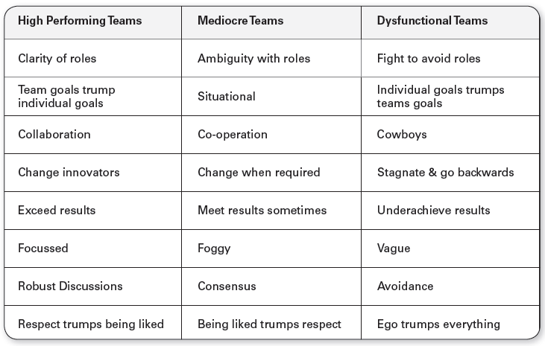

|  |  |
| --- | --- |
| **Current Team Traits and Behaviours** | **Actions to move to high performing team** |
|  |  |

*Please return online and continue with Topic 4 –* Liaise with stakeholders*.*

*----*

**Part 4 – Liaise With Stakeholders**

**ASSESSMENT INSTRUCTIONS**

You should have now read the content and completed the short answer questions for the fourth topic *‘*Liaise with stakeholders’*.*

In this Part, you are required to complete steps 1-3.

**Step 1 – Communicating Up**

Identify an issue, problem or concern your team may be experiencing. In the space below, draft an email to your manager discussing the concerns raised by your team. (100 words)

**Step 2 – Communicating Down**

Identify a new change management are planning to implement. In the space below, draft an email to your team explaining the new change. (100 words)

**Step 3 - Manager’s Sign Off**

Once you have completed all the above meet with your manager to gain feedback and get sign off for this Unit. *Please note, your manager must provide written feedback in the space below.*

If you are unable to meet with your manager there are 3 other options available for sign off:

1. Attend a Proteus Implementation Day
2. Arrange an appointment with your Proteus Coach

|  |  |  |
| --- | --- | --- |
| **Lead and Manage Tem Effectiveness – Workplace Assessment** | **Yes** | **No** |
| Did the student use leadership techniques and strategies to facilitate team cohesion and work outcomes including:   * encouraging and fostering shared understanding of purpose, roles and responsibilities * identifying and resolving problems * providing feedback to encourage, value and reward others * modelling desired behaviour and practices |  |  |
| Did the student develop policies and procedures to ensure team members take responsibility for own work and assist others to undertake required roles and responsibilities? |  |  |
| Did the student establish processes to address issues and resolve performance issues? |  |  |
| Did the student support team to meet expected performance outcomes including providing formal and informal learning opportunities as needed? |  |  |
| Did the student develop performance plans with key performance indicators (KPIs), outputs and goals for individuals or the team which incorporate input from stakeholders? |  |  |
| Did the student communicate effectively with a range of stakeholders about team performance plans and team performance? |  |  |
| Did the student facilitate two-way flow of information between team and management relevant to team performance? |  |  |
| Did the student evaluate and take necessary corrective action regarding unresolved issues, concerns and problems raised by internal or external stakeholders? |  |  |
| **Feedback – Skills Performance** |  |  |
| What feedback can you give you the staff member regarding the standard of their performance in these skills listed above? (50-100 words). Please consider areas of success and areas of development. | | |

**Managers Name:**

**Managers Job Title:**

**Managers Signature: _____________________**

**Date:**

**ASSESSMENT INSTRUCTIONS**

This is the end of the Workplace Assessment.

Please now go online to the topic menu for ‘Unit 3 – Lead and Manage Team Effectiveness’ and click on the box **‘Workplace Assessment’** to submit your Workplace Assessment.

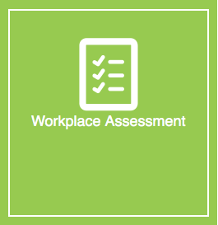

**Grading and Feedback.**

Feedback will be provided for each question through the Online Learning System. You will receive an email notification of feedback being posted.

If there are any required changes you will be given an opportunity to resubmit.

Proteus Leadership – 1300 219 903 – [online@proteusleadership.com](mailto:online@proteusleadership.com)

-- End of Document --