

Getting started Guide

- Logging in pg. 1
- Navigation pg. 2
- Course Structure pg. 3
- Email notifications pg. 3
- Support pg. 3

1. Logging in

To access the Proteus Online Learning system simply visit www.proteusenterprises.com.au/online-learning and enter your username and password in the login section.

This takes you into your online learning homepage. Your course displays in the middle of the page and shows you who your Course Coach will be.



2. Navigation

Your Course will look a bit like the screenshot below. There are 9 Modules to complete, but to get started attempt the Welcome Section. Put aside half an hour to complete this all in one sitting.

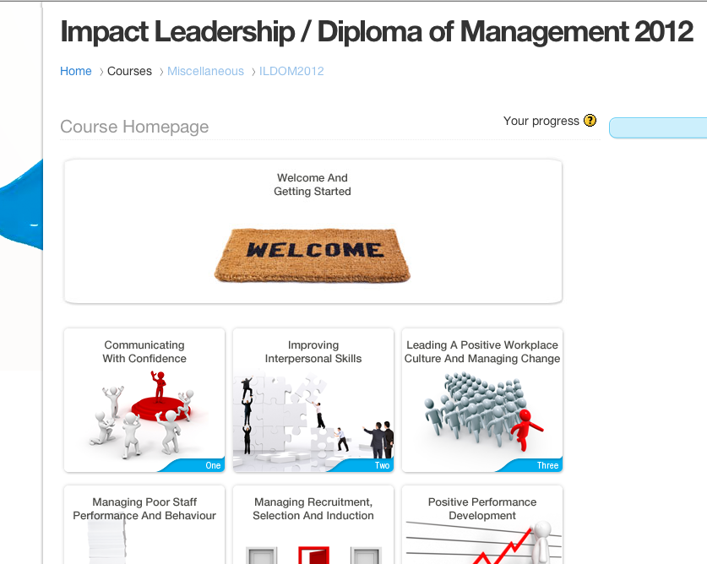

3. Course Structure

The course is broken down into 8 Leadership Modules and a final reflective paper and these can be accessed from the main landing page or 'home'.

Under each of these Modules are a series of Topics. Each module may have between 6 and 12 topics.

Modules and Topics should be completed in the order they are presented and we advise that you aim to finish a Topic in one-sitting.

Each topic may take anywhere between a few minutes to half an hour to complete.

At the end of each Topic you are required to "Submit Assessments" before moving on to the next Topic, we will show you how to do that a little later on.

If you do exit the system it will remember where you are up to in a Topic, but your answers are not submitted unless you click “Submit Assessments.”

Remember:
- Each Module is made up of several Topics
- Its advised to complete a Topic in one-sitting
- Always click 'Submit Assessments' at the end of a Topic

4. Email notifications

Once an assessment or entire module has been marked by your Course Coach you will receive an email which will tell you your assessment has been marked and give you a link so you can log in and read the feedback.

5. Support

Proteus Enterprises provides technical support to all students
Call technical support direct on:
03 8605 7400 or online@proteuscentre.com

Your course coach will provide you with assistance on the course. If you have any questions or difficulties contact them on:
1300 219 903 or via email.

