The Step by Step Process to completing and uploading this assessment
Make sure you finish the Topic before attempting the template assessment.

Step 1 – Complete the template below and save in a safe place on your computer, taking care to complete all the blank spaces
There will be multiple templates to complete as part of this Module. Once you have completed all the templates – you are ready to submit.

Step 2 – Enter the Submit Your Templates area of the Module.

Step 3 – Scroll to the bottom of the page and click the Add Submission button
Step 4 – Again scroll to the bottom of the page and ‘drag and drop’ your files into the box
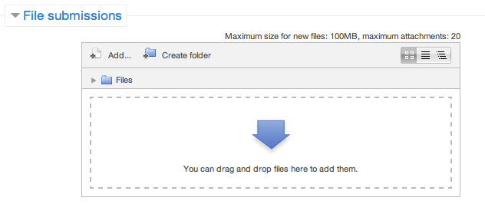
Step 5 – Once the files are uploaded, click Save Changes
Step 6 – If you are ready to submit click Submit Assignment
Step 7 – Click Continue – this will send your document for grading and you will not be able to make further changes.

Communicating With Confidence

Presentation

Using the SOSOR template below prepare a work-related presentation.
This presentation must be different from any previous presentations that you have prepared as part of the Leadership program.

DESIGN A 5-10 MINUTE PRESENTATION
RELATING TO YOUR SPECIFIC WORK AREA

INTRODUCTION

Hello, my name is…
I am here today to talk about (topic)…
SELF
My background is…

Before we start, I would like to ask…
OTHERS

Today I would like to talk about…
SCENE (4 dot points)

*
*
*
*

My OBJECTIVE today is…

As a RESULT of this you will be able to…

THE BODY:

POINT 1 (3 dot points)

POINT 2

POINT 3

POINT 4

In CONCLUSION today we have covered…

Scene: 1.
2.
3.
4.

As a Result you will now be able to…

