The Step by Step Process to completing and uploading this assessment
Make sure you finish the Topic before attempting the template assessment.

Step 1 – Complete the template below and save in a safe place on your computer, taking care to complete all the blank spaces
There will be multiple templates to complete as part of this Module. Once you have completed all the templates – you are ready to submit.

Step 2 – Enter the Submit Your Templates area of the Module.

Step 3 – Scroll to the bottom of the page and click the Add Submission button
Step 4 – Again scroll to the bottom of the page and ‘drag and drop’ your files into the box
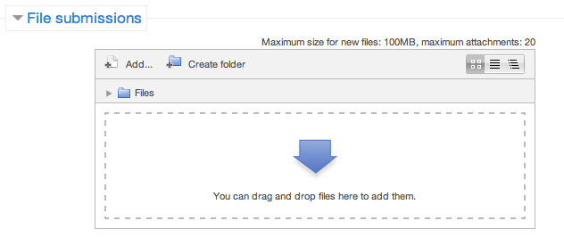
Step 5 – Once the files are uploaded, click Save Changes
Step 6 – If you are ready to submit click Submit Assignment
Step 7 – Click Continue – this will send your document for grading and you will not be able to make further changes.

Checklist For Role Shifting With “Drivers”

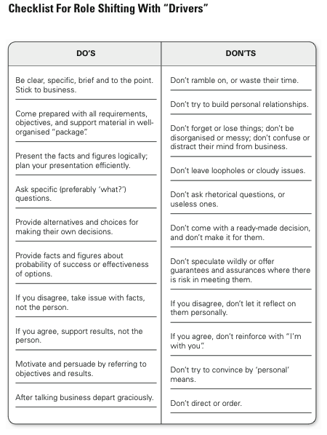
Checklist For Role Shifting With “Expressives”

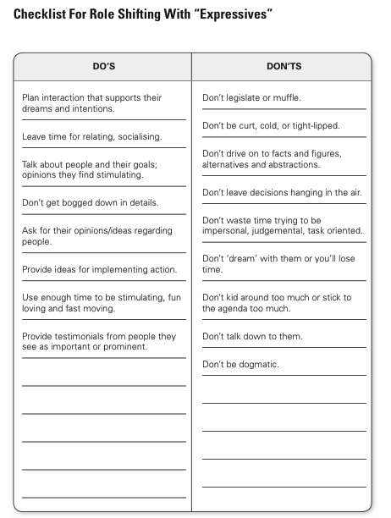
Checklist For Role Shifting With “Amiables”

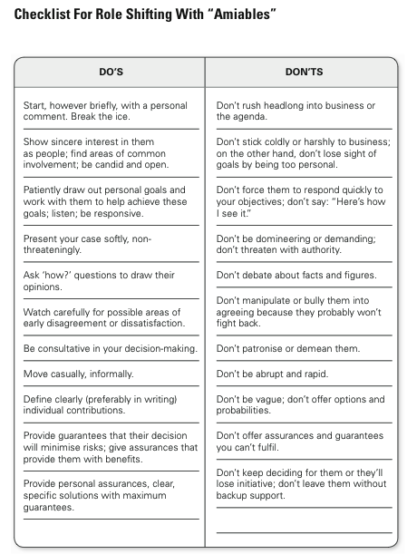
Checklist For Role Shifting With “Analyticals”

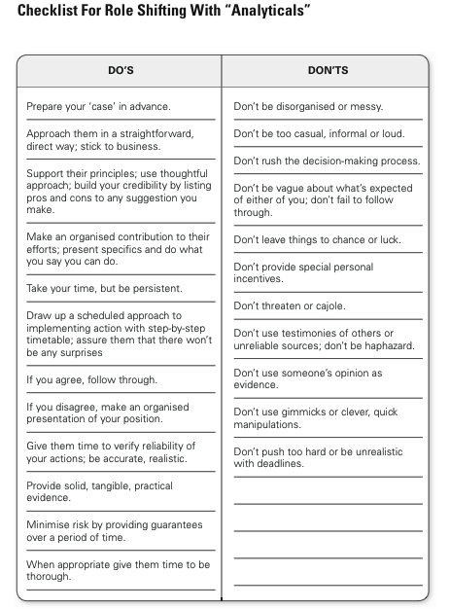

Strategies for dealing effectively with scenarios

Use the tables below to write suggestions for how to deal more effectively with the following workplace scenarios: (minimum of 4 dot points per section)

Strategies for Praise & Recognition

Style | Strategies for Praise & Recognition
Analytical

Driver

Amiable

Expressive

Strategies for Presenting a Proposal or Idea to Executive

Style | Strategies for Praise & Recognition
Analytical

Driver

Amiable

Expressive

Strategies for Resolving Conflict (or confronting an issue)

Style | Strategies for Praise & Recognition
Analytical

Driver

Amiable

Expressive

