The Step by Step Process to completing and uploading this assessment
Make sure you finish the Topic before attempting the template assessment.

Step 1 – Complete the template below and save in a safe place on your computer, taking care to complete all the blank spaces
There will be multiple templates to complete as part of this Module. Once you have completed all the templates – you are ready to submit.

Step 2 – Enter the Submit Your Templates area of the Module.

Step 3 – Scroll to the bottom of the page and click the Add Submission button
Step 4 – Again scroll to the bottom of the page and ‘drag and drop’ your files into the box
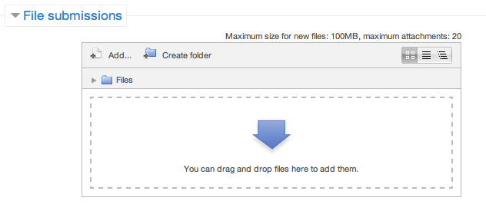
Step 5 – Once the files are uploaded, click Save Changes
Step 6 – If you are ready to submit click Submit Assignment
Step 7 – Click Continue – this will send your document for grading and you will not be able to make further changes.

Using the SOSOR Model to plan counselling & disciplinary meetings

Complete the SOSOR model using it for a counselling and a disciplinary interview for a staff member who has poor time keeping.

Counselling Interview Work Sheet

Others:
Self: | As your manager I need to discuss an issue (remember to have examples/facts)
Scene: | Today I would like to discuss the following with you:  Your Response to the Issue/Your Version of the Events  The Impact  What Changes (if appropriate)  Expected change of performance &/or behaviour  Time Frames (include suggested support/training)  Date of Review  Clarify the Consequences (if appropriate)
Result: | As a result you can go back into the workplace and perform/behave as expected and agreed.

Disciplinary Interview Work Sheet

Self: | As your manager I need to discuss an issue (remember to have examples/facts)
Others: | Introduce witnesses/support people
Scene: | Today I would like to discuss the following with you:  Your Response to the Allegations/Issue  The Impact  What Changes (Action Plan)  Expected change of performance &/or behaviour  Time Frames (include suggested support/training)  Date of Review  Clarify the Consequences
Objective: | My Objective is to clarify and get you back on track
Result: | As a result you can go back into the workplace and perform/behave as expected and agreed.

Managing Separation & Termination
Managing Poor Performance & Behaviour

Using the templates below, complete a counselling interview and disciplinary interview for a ‘real’ situation in your organisation. This may be a situation that has already been addressed or one that needs to be addressed. For confidentiality reasons please do not use actual names.

Counselling Interview Work Sheet

Others:
Self: | As your manager I need to discuss an issue (remember to have examples/facts)
Scene: | Today I would like to discuss the following with you:  Your Response to the Issue/Your Version of the Events  The Impact  What Changes (if appropriate)  Expected change of performance &/or behaviour  Time Frames (include suggested support/training)  Date of Review  Clarify the Consequences (if appropriate)
Objective: | My Objective is to clarify and get you back on track
Result: | As a result you can go back into the workplace and perform/behave as expected and agreed.
Disciplinary Interview Work Sheet

Self: | As your manager I need to discuss an issue (remember to have examples/facts)
Others: | Introduce witnesses/support people
Scene: | Today I would like to discuss the following with you:  Your Response to the Allegations/Issue  The Impact  What Changes (Action Plan)  Expected change of performance &/or behaviour  Time Frames (include suggested support/training)  Date of Review  Clarify the Consequences
Objective: | My Objective is to clarify and get you back on track
Result: | As a result you can go back into the workplace and perform/behave as expected and agreed.

