The Step by Step Process to completing and uploading this assessment
Make sure you finish the Topic before attempting the template assessment.

Step 1 – Complete the template below and save in a safe place on your computer, taking care to complete all the blank spaces
There will be multiple templates to complete as part of this Module. Once you have completed all the templates – you are ready to submit.

Step 2 – Enter the Submit Your Templates area of the Module.

Step 3 – Scroll to the bottom of the page and click the Add Submission button
Step 4 – Again scroll to the bottom of the page and ‘drag and drop’ your files into the box
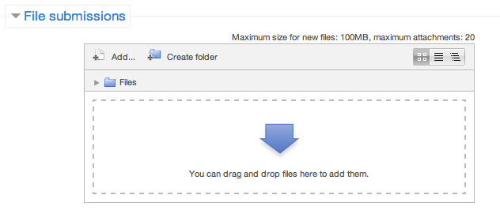
Step 5 – Once the files are uploaded, click Save Changes
Step 6 – If you are ready to submit click Submit Assignment
Step 7 – Click Continue – this will send your document for grading and you will not be able to make further changes.

Planning your Leadership Change Project
Work Breakdown Structure Activity

Using the Work Breakdown Structure (WBS), establish how you will project manage the implementation of your plan. Prioritise your tasks so that you can put them onto a Gantt Chart, which we will work through in the next section.

Work Breakdown Structure (WBS)
Make a list of six of the major tasks that need to be done to complete your project.

WBS | Phase/Tasks | Deliverables | Predecessor

Planning your Leadership Change Project
Gantt Chart Activity

Complete the Gantt Chart to represent your work breakdown structure. Record your prioritised tasks down the left hand side and then record their implementation over a 12-month period.

Project Title | Month  1 | Month  2 | Month  3 | Month  4 | Month  5 | Month  6 | Month  7 | Month  8 | Month  9 | Month  10 | Month  11 | Month  12
Task 1
Task 2
Task 3
Task 4
Task 5
Task 6

