The Step by Step Process to completing and uploading this assessment
Make sure you finish the Topic before attempting the template assessment.

Step 1 – Complete the template below and save in a safe place on your computer, taking care to complete all the blank spaces
There will be multiple templates to complete as part of this Module. Once you have completed all the templates – you are ready to submit.

Step 2 – Enter the Submit Your Templates area of the Module.

Step 3 – Scroll to the bottom of the page and click the Add Submission button
Step 4 – Again scroll to the bottom of the page and ‘drag and drop’ your files into the box
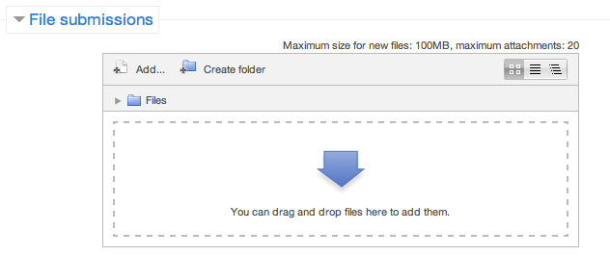
Step 5 – Once the files are uploaded, click Save Changes
Step 6 – If you are ready to submit click Submit Assignment
Step 7 – Click Continue – this will send your document for grading and you will not be able to make further changes.

Weekly Project Status Memo

Project Title: |  |  | Project No:
To:

From:

Cc:

Re:

Date:

Accomplishments this week
1.
2.
3.

Issues requiring attention
1.
2.
3.

Overall status of project (please circle)

Time: | behind target | on target |  | ahead of target
Cost: | behind target | on target |  | ahead of target
Quality: | behind target | on target |  | ahead of target

