The Step by Step Process to completing and uploading this assessment
Make sure you finish the Topic before attempting the template assessment.

Step 1 – Complete the template below and save in a safe place on your computer, taking care to complete all the blank spaces
There will be multiple templates to complete as part of this Module. Once you have completed all the templates – you are ready to submit.

Step 2 – Enter the Submit Your Templates area of the Module.

Step 3 – Scroll to the bottom of the page and click the Add Submission button
Step 4 – Again scroll to the bottom of the page and ‘drag and drop’ your files into the box
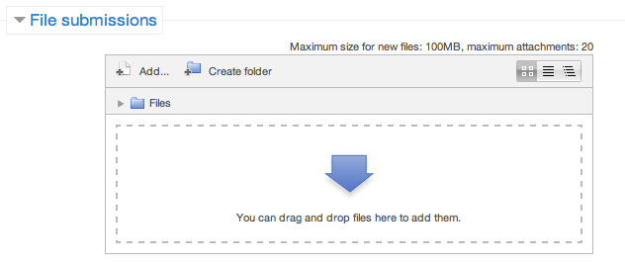
Step 5 – Once the files are uploaded, click Save Changes
Step 6 – If you are ready to submit click Submit Assignment
Step 7 – Click Continue – this will send your document for grading and you will not be able to make further changes.

CURRENT KNOWLEDGE AND SKILLS QUESTIONNAIRE

To support us in understanding your individual needs we request that you complete the following questionnaire.

Responses can be just 1-2 sentences, but please provide examples or instances where you have (or had) involvement or responsibility in the key areas covered in this program.

1. Facilitating Workplace Teams

What experience have you had motivating, mentoring, coaching & managing a team. This can be in your current or previous roles, or even outside the workplace.

2. Providing Leadership In The Workplace

(Decision making, communication processes, establishing & maintaining standards & workplace culture/image)

Leadership happens at all levels, how have you been able to lead in your current or previous workplace?

3. Establishing Effective Workplace Relationships

(Networking, conflict resolution, problem solving & managing different interpersonal styles)

How do you create and manage relationships in your current or previous workplace?

4. Managing Personal Work Priorities And Professional Development

(Establishing, prioritising and acting on professional goals. Assessment and review of those goals)

What tools have you used to help you manage your workload?

5. Establishing And Managing The Recruitment, Selection & Induction Processes

(Outline experience you have had with these processes from identification of a need to selection & induction of a successful applicant)

Even if you haven't had much experience in recruitment and selection, everyone is involved in the induction process. When someone joins the company and you welcome them you have influenced their induction.

6. Briefly explain your leadership style:

(Use whatever terms, descriptions etc. you like)

PERSONAL LEADERSHIP PROFILE

What do you believe you currently do well in your leadership role?

Are there specific skills and abilities you would like to improve on that would assist you in becoming a better leader?

What are your current personal and professional networks that could assist you in your leadership role?

What networks (internal & external) and associations, would you like to explore for future membership that would assist you in your role?

As a leader it is important that you have the skills and ability to relate to people from a range of social, cultural and ethnic backgrounds and physical and mental abilities.

Briefly outline your experience in dealing with a diversity of people and what further skills you would like to acquire.

I,

- Hereby give permission for copies of my results to be provided to my employer and Government Agencies for the purpose of Proteus Education & Training external audit requirements.
- Authorise the use of individual name and/or image as well as testimonials for RTO marketing material when applicable.

Date:

