The Step by Step Process to completing and uploading this assessment

Step 1 – Complete the template below and save in a safe place on your computer, taking care to complete all the blank spaces
Step 2 – Go back to your Internet Browser and click the orange Upload Workbook button
Step 3 – From this page click the Upload Files button
Step 4 – From this page click Add…
Step 5 – This opens a new window click Upload a File
Step 6 – Then click Choose File, Browse or Open whichever button your browser uses to locate a file
Step 7 – Click Upload This File. Wait while your file uploads
Step 8 – On the next page click Save Changes. Repeat above if you have multiple documents
Step 9 – Scroll down and click Send for Marking
Step 10 – When prompted click Continue
Step 11 – You can now close the window and return to your course

Checklist For Role Shifting With “Drivers”

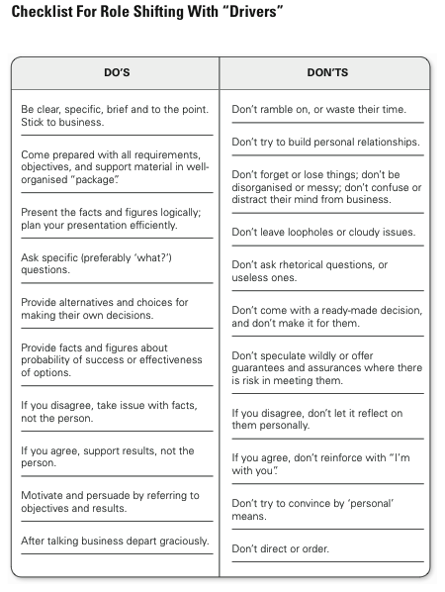
Checklist For Role Shifting With “Expressives”

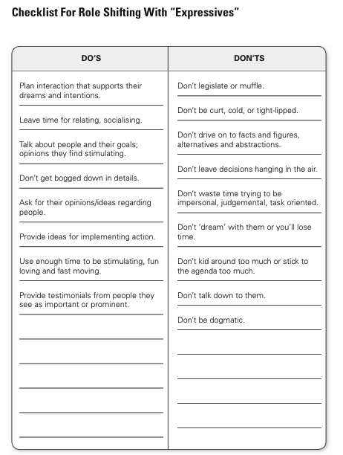
Checklist For Role Shifting With “Amiables”

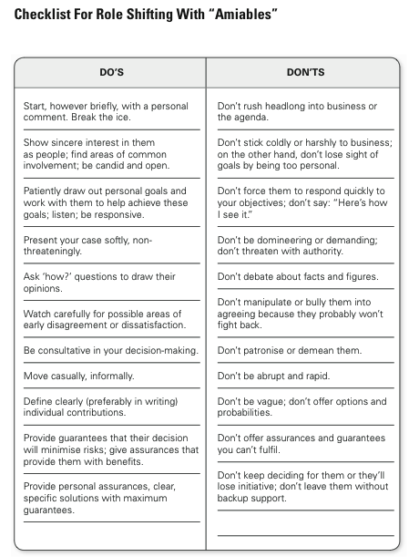
Checklist For Role Shifting With “Analyticals”

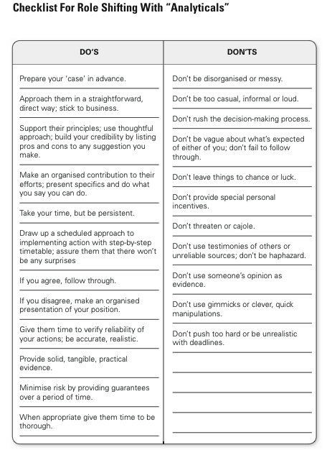

Strategies for dealing effectively with scenarios

Use the tables below to write suggestions for how to deal more effectively with the following workplace scenarios: (minimum of 4 dot points per section)

Strategies for Praise & Recognition

Style | Strategies for Praise & Recognition
Analytical

Driver

Amiable

Expressive

Strategies for Presenting a Proposal or Idea to Executive

Style | Strategies for Presenting a Proposal or Idea
Analytical

Driver

Amiable

Expressive

Strategies for Resolving Conflict (or confronting an issue)

Style | Strategies for Resolving Conflict
Analytical

Driver

Amiable

Expressive

