**The Step by Step Process to completing and uploading this assessment**

*Make sure you finish the Topic before attempting the template assessment.*

**Step 1** – Complete the template below and save in a safe place on your computer, taking care to complete all the blank spaces

*There will be multiple templates to complete as part of this Module. Once you have completed all the templates – you are ready to submit.*

**Step 2** – Enter the Submit Your Templates area of the Module.



**Step 3** – Scroll to the bottom of the page and click the ***Add Submission*** button

**Step 4** – Again scroll to the bottom of the page and *‘drag and drop’* your files into the box

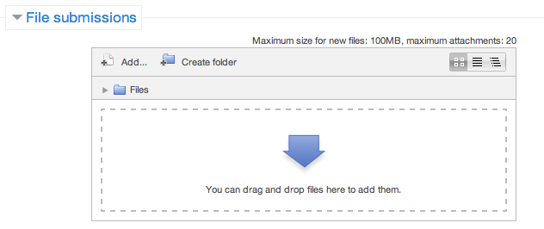

**Step 5** – Once the files are uploaded, click ***Save Changes***

**Step 6** – If you are ready to submit click ***Submit Assignment***

**Step 7** – Click ***Continue*** – this will send your document for grading and you will not be able to make further changes.

**Leading And Managing Yourself**

**Key Result Area Summary**

In the table below, list you **Key Result Areas**, and record the minutes you spend per day on each one. Along the bottom row, record the total hours worked per day (not just the time spent on Key Result Areas).

Next, add up the time worked over the week for each **Key Result Area** and record this **in hours** in the ‘Total’ column.

Finally, divide the total time worked for each **Key Result Area** by the total number of hours worked in the week, and multiply by 100 to give the percentage of available time spent on each **Key Result Area**.

|  |  |  |  |  |  |  |  |  |
| --- | --- | --- | --- | --- | --- | --- | --- | --- |
| **Key Result Area** | **Mon** | **Tue** | **Wed** | **Thu** | **Fri** | **W/E** | **Total** | **%**  **time per KRA** |
|  |  |  |  |  |  |  |  |  |
|  |  |  |  |  |  |  |  |  |
|  |  |  |  |  |  |  |  |  |
|  |  |  |  |  |  |  |  |  |
|  |  |  |  |  |  |  |  |  |
|  |  |  |  |  |  |  |  |  |
| Number of hours worked per day |  |  |  |  |  |  |  |  |

**Reflection**

**Once you have completed the Template above answer the following 4 questions.**

**1. Does the time spent on Key Result Areas align with your priorities?**

Your Response:

**2. Could more time and focus be given to certain Key Result Areas? Specify:**

Your Response:

**3. Identify six ways to improve your time management**

Your response:



**4. Were your findings in line with the organisational expectations of the role?**

Your Response: