**The Step by Step Process to completing and uploading this assessment**

*Make sure you finish the Topic before attempting the template assessment.*

**Step 1** – Complete the template below and save in a safe place on your computer, taking care to complete all the blank spaces

*There will be multiple templates to complete as part of this Module. Once you have completed all the templates – you are ready to submit.*

**Step 2** – Enter the Submit Your Templates area of the Module.



**Step 3** – Scroll to the bottom of the page and click the ***Add Submission*** button

**Step 4** – Again scroll to the bottom of the page and *‘drag and drop’* your files into the box

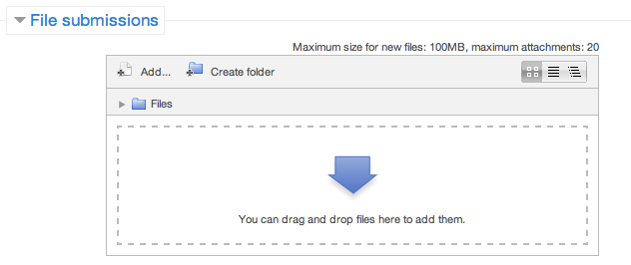

**Step 5** – Once the files are uploaded, click ***Save Changes***

**Step 6** – If you are ready to submit click ***Submit Assignment***

**Step 7** – Click ***Continue*** – this will send your document for grading and you will not be able to make further changes.

**Leading And Managing Yourself**

**Weekly Snapshot**

|  |  |  |  |  |  |
| --- | --- | --- | --- | --- | --- |
| **Time:** | **Mon** | **Tue** | **Wed** | **Thu** | **Fri** |
| 8am |  |  |  |  |  |
| 9am |  |  |  |  |  |
| 10am |  |  |  |  |  |
| 11am |  |  |  |  |  |
| 12pm |  |  |  |  |  |
| 1pm |  |  |  |  |  |
| 2pm |  |  |  |  |  |
| 3pm |  |  |  |  |  |
| 4pm |  |  |  |  |  |
| 5pm |  |  |  |  |  |
| 6pm |  |  |  |  |  |