**The Step by Step Process to completing and uploading this assessment**

*Make sure you finish the Topic before attempting the template assessment.*

**Step 1** – Complete the template below and save in a safe place on your computer, taking care to complete all the blank spaces

*There will be multiple templates to complete as part of this Module. Once you have completed all the templates – you are ready to submit.*

**Step 2** – Enter the Submit Your Templates area of the Module.



**Step 3** – Scroll to the bottom of the page and click the ***Add Submission*** button

**Step 4** – Again scroll to the bottom of the page and *‘drag and drop’* your files into the box

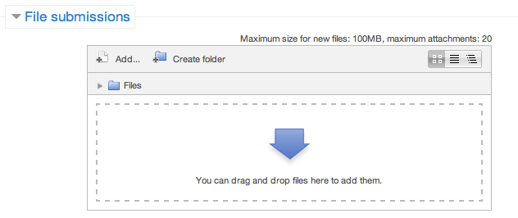

**Step 5** – Once the files are uploaded, click ***Save Changes***

**Step 6** – If you are ready to submit click ***Submit Assignment***

**Step 7** – Click ***Continue*** – this will send your document for grading and you will not be able to make further changes.

**Leading And Managing Yourself**

**Your Personal Level Of Responsibility And Accountability**

**In the following table:**

1. List 3 of your KRAs from earlier in the module
2. Rank the level of ownership you take for that KRS, from 1-10 (1 not taking any responsibility to 10 taking full ownership)
3. What obstacle is blocking you increasing this level of ownership?
4. If this obstacle were removed, what would you do differently? (Action)
5. What is your commitment for the future in regard to taking ownership?

|  |  |  |  |
| --- | --- | --- | --- |
| **KRAs** | **Ranking** | **Obstacles** | **Action** |
| KRA 1 |  |  |  |
| KRA 2 |  |  |  |
| KRA 3 |  |  |  |
| My commitment to taking ownership | | | |