**The Step by Step Process to completing and uploading this assessment**

*Make sure you finish the Topic before attempting the template assessment.*

**Step 1** – Complete the template below and save in a safe place on your computer, taking care to complete all the blank spaces

*There will be multiple templates to complete as part of this Module. Once you have completed all the templates – you are ready to submit.*

**Step 2** – Enter the Submit Your Templates area of the Module.



**Step 3** – Scroll to the bottom of the page and click the ***Add Submission*** button

**Step 4** – Again scroll to the bottom of the page and *‘drag and drop’* your files into the box

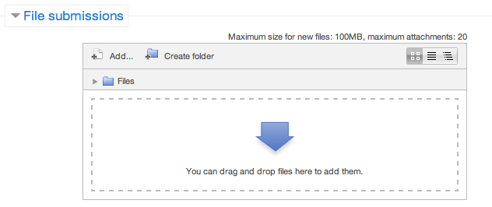

**Step 5** – Once the files are uploaded, click ***Save Changes***

**Step 6** – If you are ready to submit click ***Submit Assignment***

**Step 7** – Click ***Continue*** – this will send your document for grading and you will not be able to make further changes.

**Leading And Managing Yourself**

**Professional Development Plan**

Gather feedback from your manager, colleagues and clients and then use this template to take feedback gained and turn it into positive action. Again, list your KRAs. Identify development activity, give timeframes (eg 2 weeks, 6 months), describe the action you will need to take to get there and finally include what records or documents that can be used to show the improved results for each KRA.

|  |  |  |  |  |
| --- | --- | --- | --- | --- |
| **KRAs** | **Suggested Development** | **Timeframes** | **Action To Make It Happen** | **Approval & Communication** |
| 1. |  |  |  |  |
| 2. |  |  |  |  |
| 3. |  |  |  |  |
| 4. |  |  |  |  |
| 5. |  |  |  |  |
| 6. |  |  |  |  |