**The Step by Step Process to completing and uploading this assessment**

*Make sure you finish the Topic before attempting the template assessment.*

**Step 1** – Complete the template below and save in a safe place on your computer, taking care to complete all the blank spaces

*There will be multiple templates to complete as part of this Module. Once you have completed all the templates – you are ready to submit.*

**Step 2** – Enter the Submit Your Templates area of the Module.



**Step 3** – Scroll to the bottom of the page and click the ***Add Submission*** button

**Step 4** – Again scroll to the bottom of the page and *‘drag and drop’* your files into the box

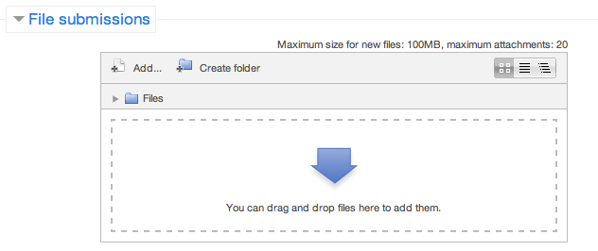

**Step 5** – Once the files are uploaded, click ***Save Changes***

**Step 6** – If you are ready to submit click ***Submit Assignment***

**Step 7** – Click ***Continue*** – this will send your document for grading and you will not be able to make further changes.

**Leading And Managing Yourself**

**Decision Making Template**

The Problem / Challenge:

|  |  |
| --- | --- |
| **Step 1 – Identify the problem clearly** | |
| Is this really your decision or someone else’? | YES/NO |
| Do you really need to make a decision? | YES/NO |
| When does the decision need to be made? |  |
| Why is this decision important to you? |  |
| Who will be affected by this decision? |  |

|  |  |
| --- | --- |
| **Step 2 – Establish objectives** | |
| My objective is to… |  |
| My decision must… |  |
| It would be nice if my decision… |  |

|  |  |
| --- | --- |
| **Step 3 – Generate alternative solutions** | |
| 1. | 6. |
| 2. | 7. |
| 3. | 8. |
| 4. | 9. |
| 5. | 10. |

|  |
| --- |
| **Step 4 – Evaluate alternatives and select the most suitable** |
| My chosen solution: |
| Why: |

|  |  |
| --- | --- |
| **Step 5 – Get started** | |
| **Plan** – What? How? Who? Where? When? | |
|  | |
| **Manage Risk – What if…?** | |
| Possible Risk | How will I manage it? |
|  |  |
|  |  |
|  |  |
|  |  |
|  |  |
| **Communicate** | |
| Who needs to know? | What do they need to know? |
|  |  |
|  |  |
|  |  |
|  |  |

|  |  |
| --- | --- |
| **Step 6 – Evaluate** | |
| Are the outcomes what you expected? |  |
| Are you happy with the outcomes? |  |
| Do you want to let the decision stand or would you like to make some adjustments? |  |

**Leading And Managing Yourself**

**Gaining Stakeholder Approval Of Your Decision**

To ensure you give your decisions the best chance of success, you need to both sell them effectively and gain stakeholder support.

So let’s determine who your stakeholders are and what their needs are.

|  |  |
| --- | --- |
| **Stakeholders** | **Their Individual Needs** |
|  |  |
|  |  |
|  |  |
|  |  |
|  |  |

**Leading And Managing Yourself**

**Monitoring And Getting Feedback On Your Decisions**

The best way to identify if stakeholders support your decisions is to gain feedback.

What methods will you use to get this feedback and what actions will you take to ensure feedback is acted on?

|  |  |
| --- | --- |
| **Methods** | **Action** |
| Eg. Questions after presentation | * Seek answers to all questions and ensure they are fed back to all stakeholders * Create an online method of feedback for after your presentation |
|  |  |
|  |  |
|  |  |