**The Step by Step Process to completing and uploading this assessment**

*Make sure you finish the Topic before attempting the template assessment.*

**Step 1** – Complete the template below and save in a safe place on your computer, taking care to complete all the blank spaces

*There will be multiple templates to complete as part of this Module. Once you have completed all the templates – you are ready to submit.*

**Step 2** – Enter the Submit Your Templates area of the Module.



**Step 3** – Scroll to the bottom of the page and click the ***Add Submission*** button

**Step 4** – Again scroll to the bottom of the page and *‘drag and drop’* your files into the box

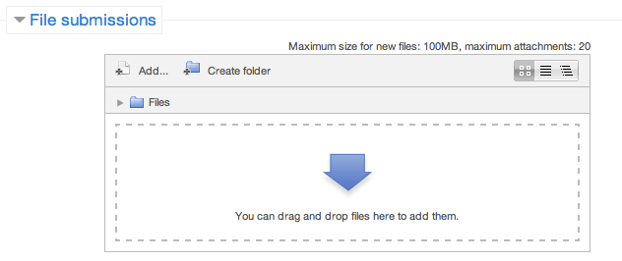

**Step 5** – Once the files are uploaded, click ***Save Changes***

**Step 6** – If you are ready to submit click ***Submit Assignment***

**Step 7** – Click ***Continue*** – this will send your document for grading and you will not be able to make further changes.

**Leading And Managing Yourself**

**Developing A Plan For Action**

**Using this template develop an action plan for something you have always wanted to do.**

|  |  |
| --- | --- |
| What is your idea? |  |
| Decide where you are (current situation) |  |
| What do you want? |  |
| What will it take to get there? |  |

|  |  |
| --- | --- |
| **Idea** |  |
| What will it look like? |  |
| When will I start? |  |
| Steps |  |
| How will I evaluate? |  |