**The Step by Step Process to completing and uploading this assessment**

*Make sure you finish the Topic before attempting the template assessment.*

**Step 1** – Complete the template below and save in a safe place on your computer, taking care to complete all the blank spaces

*There will be multiple templates to complete as part of this Module. Once you have completed all the templates – you are ready to submit.*

**Step 2** – Enter the Submit Your Templates area of the Module.



**Step 3** – Scroll to the bottom of the page and click the ***Add Submission*** button

**Step 4** – Again scroll to the bottom of the page and *‘drag and drop’* your files into the box

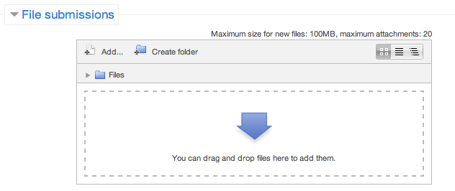

**Step 5** – Once the files are uploaded, click ***Save Changes***

**Step 6** – If you are ready to submit click ***Submit Assignment***

**Step 7** – Click ***Continue*** – this will send your document for grading and you will not be able to make further changes.

**Leading And Managing Yourself**

**Daily Activity Planning**

**List the essential and important activities that you will have to manage on your next day in the workplace.**

There will be some items that must be done in order to avoid serious consequences. There will be meetings or appointments that require a certain quantity of time. These items we will label as ‘essential’. These essential items need to have time scheduled to be undertaken or completed.

Next, list the activities or work that could possibly be done today, but needs to be completed within the next few days. We will label these items  
as ‘important’. Failure to complete them on a particular day will not necessarily cause serious problems.

|  |  |  |
| --- | --- | --- |
| **Activities List** | **Time Required to Complete** | **Comments** |
| Essential Activities |  |  |
| Important Activities |  |  |