**The Step by Step Process to completing and uploading this assessment**

*Make sure you finish the Topic before attempting the template assessment.*

**Step 1** – Complete the template below and save in a safe place on your computer, taking care to complete all the blank spaces

*There will be multiple templates to complete as part of this Module. Once you have completed all the templates – you are ready to submit.*

**Step 2** – Enter the Submit Your Templates area of the Module.



**Step 3** – Scroll to the bottom of the page and click the ***Add Submission*** button

**Step 4** – Again scroll to the bottom of the page and *‘drag and drop’* your files into the box

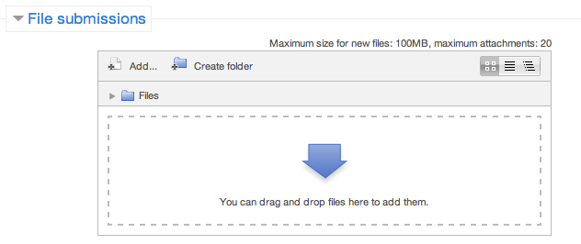

**Step 5** – Once the files are uploaded, click ***Save Changes***

**Step 6** – If you are ready to submit click ***Submit Assignment***

**Step 7** – Click ***Continue*** – this will send your document for grading and you will not be able to make further changes.

**Building Effective And Innovative Teams**

**Ideas Car Park**

Your team will come up with many ideas and not all are either suitable or timely. A great way to keep these ideas alive is to create a ‘car park’ for future opportunities. A Car Park register will guarantee the ideas don’t get forgotten, as they could be very advantageous for the business later on.

Once you have logged an idea in the car park, how will you communicate the action taken (or not taken) to relevant colleagues.

|  |  |  |
| --- | --- | --- |
| **Date** | **Idea.** | **Reason for no action** |
|  |  | Reason for no Action:  Communication:  Revisit Date: |
|  |  | Reason for no Action:  Communication:  Revisit Date: |
|  |  | Reason for no Action:  Communication:  Revisit Date: |
|  |  | Reason for no Action:  Communication:  Revisit Date: |