**The Step by Step Process to completing and uploading this assessment**

*Make sure you finish the Topic before attempting the template assessment.*

**Step 1** – Complete the template below and save in a safe place on your computer, taking care to complete all the blank spaces

*There will be multiple templates to complete as part of this Module. Once you have completed all the templates – you are ready to submit.*

**Step 2** – Enter the Submit Your Templates area of the Module.



**Step 3** – Scroll to the bottom of the page and click the ***Add Submission*** button

**Step 4** – Again scroll to the bottom of the page and *‘drag and drop’* your files into the box

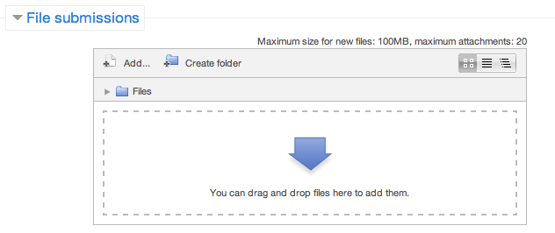

**Step 5** – Once the files are uploaded, click ***Save Changes***

**Step 6** – If you are ready to submit click ***Submit Assignment***

**Step 7** – Click ***Continue*** – this will send your document for grading and you will not be able to make further changes.

**Make A Presentation**

**My Big Workplace Idea**

It is now time to construct a full presentation on an idea you would like to introduce and implement into your department from your ideas car park in the previous module. You will then present to your group and gain feedback. Prior to commencing preparation, complete the checklist below. This will help to make your presentation more relevant and ensure better outcomes.

**Presentation Checklist**

|  |  |
| --- | --- |
| **Checklist** | **Actions** |
| **Who is your audience?** |  |
| **What are some of the key characteristics of your audience?** (eg. Age, cultural, educational, gender, language, physical ability and experience with the topic). |  |
| **What visual aids and materials will you use in your presentation?** |  |
| **What examples will you use to illustrate your key points?** |  |
| **What persuasive communication techniques will you use?** |  |
| **How will you build rapport and make your presentation fun and interactive?** |  |
| **How will you give participants opportunities to seek clarification of central concepts during or after the presentation?** |  |

**My BIG Idea:**

**INTRODUCTION**

*Hello, my name is…*

*I am here today to talk about (topic)…*

**SELF**

*My background is…*

*Before we start, I would like to ask…*

**OTHERS**

*Today I would like to talk about…*

**SCENE (4 dot points)**

*

*

*

*

*My* **OBJECTIVE** *today is…*

As a **RESULT** of this you will be able to*…*

**THE BODY**

**Point 1**

*

*

*

**Point 2**

*

*

*

**Point 3**

*

*

*

**Point 4**

*

*

*

*In* **CONCLUSION** *today we have covered…*

**Scene:**

*

*

*

*

As a **RESULT** you will be able to*…*

**Personal Presentation Evaluation**

How would you rate your presentation? Make general comments for improving each of the areas below.

|  |
| --- |
| **Preparation** |
| **Content** |
| **Delivery** |
| **Engagement** |
| **Meeting your objective** |
| **Results for the listener** |

**Feedback From The Group About Your Presentation**

Write down feedback as given to you.

|  |  |
| --- | --- |
| **Comments** | **Actions Required** |
|  |  |
|  |  |
|  |  |
|  |  |
|  |  |
|  |  |

**Your Feedback For Other Presenters**

|  |  |
| --- | --- |
| **Presenter** | **Feedback** |
|  |  |
|  |  |
|  |  |
|  |  |
|  |  |
|  |  |