**The Step by Step Process to completing and uploading this assessment**

*Make sure you finish the Topic before attempting the template assessment.*

**Step 1** – Complete the template below and save in a safe place on your computer, taking care to complete all the blank spaces

*There will be multiple templates to complete as part of this Module. Once you have completed all the templates – you are ready to submit.*

**Step 2** – Enter the Submit Your Templates area of the Module.



**Step 3** – Scroll to the bottom of the page and click the ***Add Submission*** button

**Step 4** – Again scroll to the bottom of the page and *‘drag and drop’* your files into the box

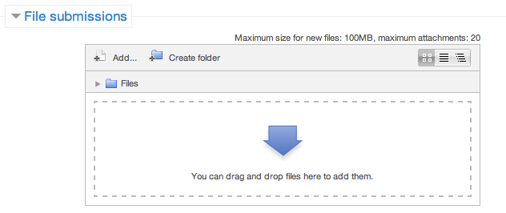

**Step 5** – Once the files are uploaded, click ***Save Changes***

**Step 6** – If you are ready to submit click ***Submit Assignment***

**Step 7** – Click ***Continue*** – this will send your document for grading and you will not be able to make further changes.

**Make A Presentation**

**Building An Innovative Team Presentation**

*Hello, my name is…*

*I am here today to talk about (topic)…*

**SELF**

*My background is…*

*Before we start, I would like to ask…*

**OTHERS**

*Today I would like to talk about…*

**SCENE (4 dot points)**

*

*

*

*

*My* **OBJECTIVE** *today is…*

As a **RESULT** of this you will be able to*…*

**THE BODY**

**Point 1**

*

*

*

**Point 2**

*

*

*

**Point 3**

*

*

*

**Point 4**

*

*

*

*In* **CONCLUSION** *today we have covered…*

**Scene:**

*

*

*

*

As a **RESULT** you will be able to*…*