**The Step by Step Process to completing and uploading this assessment**

*Make sure you finish the Topic before attempting the template assessment.*

**Step 1** – Complete the template below and save in a safe place on your computer, taking care to complete all the blank spaces

*There will be multiple templates to complete as part of this Module. Once you have completed all the templates – you are ready to submit.*

**Step 2** – Enter the Submit Your Templates area of the Module.



**Step 3** – Scroll to the bottom of the page and click the ***Add Submission*** button

**Step 4** – Again scroll to the bottom of the page and *‘drag and drop’* your files into the box

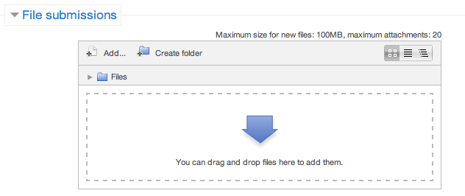

**Step 5** – Once the files are uploaded, click ***Save Changes***

**Step 6** – If you are ready to submit click ***Submit Assignment***

**Step 7** – Click ***Continue*** – this will send your document for grading and you will not be able to make further changes.

**Delivering Exceptional Customer Service**

**Developing And Implementing A Customer Service Action Plan**

**Create A Customer Service Action Plan**

You have been appointed by your executive team to develop and implement a ‘customer first’ program for your team/department over a six month period. You have been given two weeks to prepare a plan and present back to the executive team.

**What is your overall service objective:**

(i.e. what do you want to achieve from your “Customer First” program?)

**Developing And Implementing A Customer Service Action Plan**

Think about some of the concepts we have already discussed in Module 1 and 2. Taking Responsibility, Motivation, Delegation, Low Effort/High Reward, Brainstorming/6 Hats and then answer the following questions.

|  |  |
| --- | --- |
| **How will you go about changing the culture permanently in your area?** |  |
| **How will you handle the negative people?** |  |
| **How will you motivate the people to make positive changes?** |  |
| **What evaluation methods will you put in place?** |  |

**Customer Service Action Plan**

|  |  |
| --- | --- |
| **What does your team/department currently do well?** |  |
| **How can you develop these strengths?** |  |

**Customer Service Action Plan**

**Action Plan**

List ways in which you believe your team/department can improve its customer service.

|  |  |
| --- | --- |
| **Areas for Improvement** | **Ideas for Improvement** |
|  |  |
|  |  |
|  |  |
|  |  |
|  |  |
|  |  |

Using the template on the following pages, take the areas of improvement for your team or department’s customer service approach that you would like to see improved. Identify who the customers that will be impacted are, then develop an action plan by recommending a change, outlining how you will do this, who is responsible, when the change will take place and how you will gather feedback for the change.

**Customer Service Action Plan**

**Improvement Idea 1**

|  |  |
| --- | --- |
| **Areas for Improvement** |  |
| **Ideas for Improvement** |  |
| **Customers Impacted** |  |
| **How will you implement?** |  |
| **How will you gather feedback?** |  |
| **Who will be responsible?** |  |
| **When will the change take place?** |  |

**Customer Service Action Plan**

**Improvement Idea 2**

|  |  |
| --- | --- |
| **Areas for Improvement** |  |
| **Ideas for Improvement** |  |
| **Customers Impacted** |  |
| **How will you implement?** |  |
| **How will you gather feedback?** |  |
| **Who will be responsible?** |  |
| **When will the change take place?** |  |

**Customer Service Action Plan**

**Improvement Idea 3**

|  |  |
| --- | --- |
| **Areas for Improvement** |  |
| **Ideas for Improvement** |  |
| **Customers Impacted** |  |
| **How will you implement?** |  |
| **How will you gather feedback?** |  |
| **Who will be responsible?** |  |
| **When will the change take place?** |  |

**Customer Service Action Plan**

**Improvement Idea 4**

|  |  |
| --- | --- |
| **Areas for Improvement** |  |
| **Ideas for Improvement** |  |
| **Customers Impacted** |  |
| **How will you implement?** |  |
| **How will you gather feedback?** |  |
| **Who will be responsible?** |  |
| **When will the change take place?** |  |

**Customer Service Action Plan**

**Improvement Idea 5**

|  |  |
| --- | --- |
| **Areas for Improvement** |  |
| **Ideas for Improvement** |  |
| **Customers Impacted** |  |
| **How will you implement?** |  |
| **How will you gather feedback?** |  |
| **Who will be responsible?** |  |
| **When will the change take place?** |  |

**Customer Service Action Plan**

**Improvement Idea 6**

|  |  |
| --- | --- |
| **Areas for Improvement** |  |
| **Ideas for Improvement** |  |
| **Customers Impacted** |  |
| **How will you implement?** |  |
| **How will you gather feedback?** |  |
| **Who will be responsible?** |  |
| **When will the change take place?** |  |