**The Step by Step Process to completing and uploading this assessment**

*Make sure you finish the Topic before attempting the template assessment.*

**Step 1** – Complete the template below and save in a safe place on your computer, taking care to complete all the blank spaces

*There will be multiple templates to complete as part of this Module. Once you have completed all the templates – you are ready to submit.*

**Step 2** – Enter the Submit Your Templates area of the Module.



**Step 3** – Scroll to the bottom of the page and click the ***Add Submission*** button

**Step 4** – Again scroll to the bottom of the page and *‘drag and drop’* your files into the box

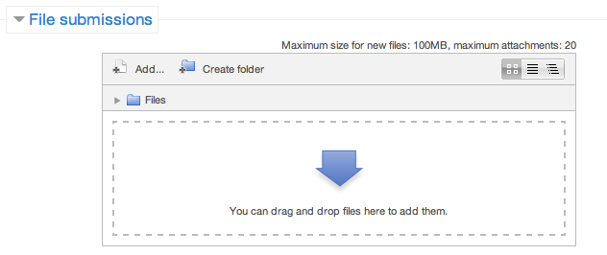

**Step 5** – Once the files are uploaded, click ***Save Changes***

**Step 6** – If you are ready to submit click ***Submit Assignment***

**Step 7** – Click ***Continue*** – this will send your document for grading and you will not be able to make further changes.

**Delivering Exceptional Customer Service**

**Exploring And Understanding Your Customer**

|  |  |
| --- | --- |
| **Customer Characteristics** | **A Well Known Customer** |
| **Who they are**  Are you selling to individuals or businesses?  Individuals – what is their age, gender, marital status and occupation?  Businesses – what size and kind (eg. Small business or multinational) |  |
| **What they do**  Are you selling to individuals or businesses?  Individuals – what is their occupation and interests?  Businesses – what is their business aiming to achieve? |  |
| **Why they buy** |  |
| **When they buy**  What time of day does your customer purchase? |  |
| **How they buy**  What method does your customer use to purchase? (Website, face-to-face etc.) |  |
| **How much money they have**  What can your customer afford? |  |
| **What makes them feel good about buying?**  What makes them tick? |  |
| **What they expect of you** |  |
| **What they think about you** |  |
| **What they think about your competitors**  Stay ahead of your rivals! |  |