**The Step by Step Process to completing and uploading this assessment**

*Make sure you finish the Topic before attempting the template assessment.*

**Step 1** – Complete the template below and save in a safe place on your computer, taking care to complete all the blank spaces

*There will be multiple templates to complete as part of this Module. Once you have completed all the templates – you are ready to submit.*

**Step 2** – Enter the Submit Your Templates area of the Module.



**Step 3** – Scroll to the bottom of the page and click the ***Add Submission*** button

**Step 4** – Again scroll to the bottom of the page and *‘drag and drop’* your files into the box

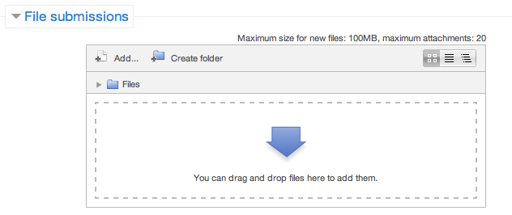

**Step 5** – Once the files are uploaded, click ***Save Changes***

**Step 6** – If you are ready to submit click ***Submit Assignment***

**Step 7** – Click ***Continue*** – this will send your document for grading and you will not be able to make further changes.

**Exploring And Understanding Your Customer**

|  |  |  |
| --- | --- | --- |
| **Customer Name** |  |  |
| What do they need you / your team for? |  |  |
| What do they expect of you / your team? |  |  |
| What is their perception of you / your team? |  |  |
| What do they think of your competitors? |  |  |
| How can you use your strengths to meet their needs? |  |  |