**The Step by Step Process to completing and uploading this assessment**

*Make sure you finish the Topic before attempting the template assessment.*

**Step 1** – Complete the template below and save in a safe place on your computer, taking care to complete all the blank spaces

*There will be multiple templates to complete as part of this Module. Once you have completed all the templates – you are ready to submit.*

**Step 2** – Enter the Submit Your Templates area of the Module.



**Step 3** – Scroll to the bottom of the page and click the ***Add Submission*** button

**Step 4** – Again scroll to the bottom of the page and *‘drag and drop’* your files into the box

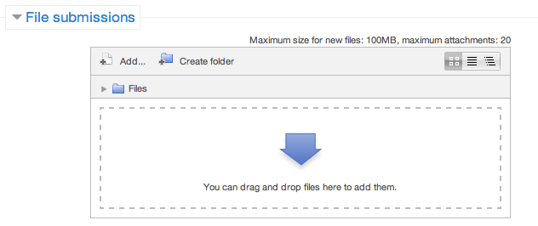

**Step 5** – Once the files are uploaded, click ***Save Changes***

**Step 6** – If you are ready to submit click ***Submit Assignment***

**Step 7** – Click ***Continue*** – this will send your document for grading and you will not be able to make further changes.

**Operation Plan**

**Creating An Operational Plan**

**Activity**

**Developing An Operational Plan**

It is now time to develop an operational plan for your team/department.

**Step 1 –** You must first understand your team’s capabilities and the key stakeholders’ priorities.

|  |  |
| --- | --- |
| **Step 1 - Gathering Information** | |
| **SWOT** | You have already completed your SWOT for your team, however you may like to unclip this and add further detail (pg 9). |
| **Who are the Stakeholders?** |  |
| **How will you get their input?** |  |

**Activity**

**Developing An Operational Plan**

It is now time to develop an operational plan for your team/department.

**Step 2 –** Based on your strengths and weaknesses and your predictions of the future what is a project, idea or initiative that you’d like to put a plan around?

|  |  |
| --- | --- |
| **Step 2 - Objective** | |
| **Plan Name:** |  |
| **Objective**  Ensure it is SMART and in line with the organisational strategy |  |

**Activity**

**Developing An Operational Plan**

**Step 3 –** It’s time to put together the basic operational plan detailing who will do what.

|  |  |  |  |  |
| --- | --- | --- | --- | --- |
| **Step 3 – Operational Plan** | | | | |
| **ID** | **What** | **Who** | **When** | **How Much** |
| **1.** |  |  |  |  |
| **2.** |  |  |  |  |
| **3.** |  |  |  |  |
| **4.** |  |  |  |  |
| **5.** |  |  |  |  |
| 6. |  |  |  |  |

**Activity**

**Developing An Operational Plan**

**Step 4 –** Once you have decided how to spread the workload you will need to communicate to the team their responsibilities. How will you use each of the below to ensure things get done and done right?

|  |  |  |  |
| --- | --- | --- | --- |
| **Step 4 – Instruct, Discipline and Encourage for Performance** | | | |
| **ID** | **Instruct** | **Discipline** | **Encourage** |
| **1.** |  |  |  |
| **2.** |  |  |  |
| **3.** |  |  |  |
| **4.** |  |  |  |
| **5.** |  |  |  |
| 6. |  |  |  |

**Activity**

**Developing An Operational Plan**

**Step 5 –** It is important to document how each task will be completed. This will ensure clarity but also provide a good contingency planning document.

|  |  |
| --- | --- |
| **Step 5 – Procedures** | |
| **ID** | **Procedure** |
| **1.** |  |
| **2.** |  |
| **3.** |  |
| **4.** |  |
| **5.** |  |
| 6. |  |

**Activity**

**Developing An Operational Plan**

**Step 6 –** Now that you have the what and the how in place, you need to determine some measures to help you along the way.

|  |  |
| --- | --- |
| **Step 6 – Measurements** | |
| **KPIs**  How will you know if your plan is on track? Consider measurements of performance such as % increase/decrease | **1.**  **2.**  **3.**  **4.** |
| **Step 7 – Resources** | |
| **Financial**  (budget, purchasing) |  |
| **Human**  (recruitment, training, project staff) |  |

**Activity**

**Developing An Operational Plan**

|  |  |
| --- | --- |
| **Step 8 – Approval** | |
| **Who are the Stakeholders who need to approve?** |  |
| **How will you get their approval?** |  |
| **Step 9 – Evaluation** | |
| **How will you evaluate the success of the plan?** |  |