**The Step by Step Process to completing and uploading this assessment**

*Make sure you finish the Topic before attempting the template assessment.*

**Step 1** – Complete the template below and save in a safe place on your computer, taking care to complete all the blank spaces

*There will be multiple templates to complete as part of this Module. Once you have completed all the templates – you are ready to submit.*

**Step 2** – Enter the Submit Your Templates area of the Module.



**Step 3** – Scroll to the bottom of the page and click the ***Add Submission*** button

**Step 4** – Again scroll to the bottom of the page and *‘drag and drop’* your files into the box

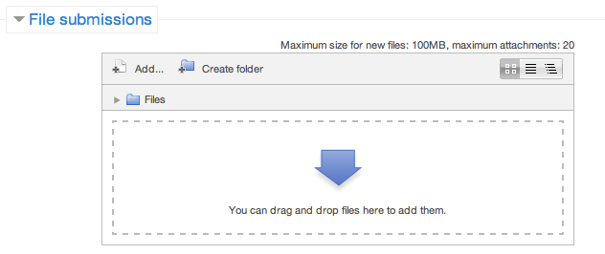

**Step 5** – Once the files are uploaded, click ***Save Changes***

**Step 6** – If you are ready to submit click ***Submit Assignment***

**Step 7** – Click ***Continue*** – this will send your document for grading and you will not be able to make further changes.

**Activity**

**SWOT Analysis**

Consider your team and conduct the SWOT analysis below.

|  |  |  |
| --- | --- | --- |
|  | **Helpful** *to achieving the objective* | **Harmful** *to achieving the objective* |
| **Internal origin**  *(attributes of the organisation)* | **STRENGTHS** | **WEAKNESSES** |
| **External origin**  *(attributes of the environment)* | **OPPORTUNITIES** | **THREATS** |

Once you have clarity over where you are, it’s now time to set the vision with an objective and measurements of success with Key Performance Indicators (KPIs).