**The Step by Step Process to completing and uploading this assessment**

*Make sure you finish the Topic before attempting the template assessment.*

**Step 1** – Complete the template below and save in a safe place on your computer, taking care to complete all the blank spaces

*There will be multiple templates to complete as part of this Module. Once you have completed all the templates – you are ready to submit.*

**Step 2** – Enter the Submit Your Templates area of the Module.



**Step 3** – Scroll to the bottom of the page and click the ***Add Submission*** button

**Step 4** – Again scroll to the bottom of the page and *‘drag and drop’* your files into the box

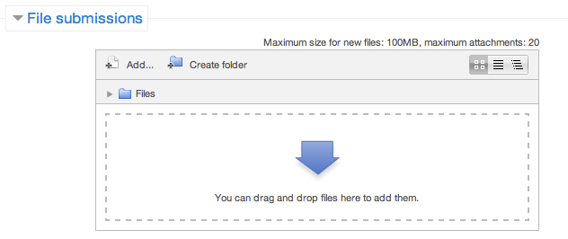

**Step 5** – Once the files are uploaded, click ***Save Changes***

**Step 6** – If you are ready to submit click ***Submit Assignment***

**Step 7** – Click ***Continue*** – this will send your document for grading and you will not be able to make further changes.

**Presentation**

**Managing Risk In The Workplace**

**Managing Risk In The Workplace Presentation**

Construct a presentation on one of the following topics:

1. Communicating the importance of WHS to your staff
2. Presenting a new WHS plan to your Management
3. How to set up a WHS plan for your department to your team
4. The legislation of WHS

**Presentation Checklist**

|  |  |
| --- | --- |
| **Checklist** | **Action** |
| Who is your audience? |  |
| What are some of the key characteristics of your audience? (eg. Age, cultural, educational, gender, language, physical ability and experience  with the topic). |  |
| What visual aids and materials will you use in your presentation? |  |
| What examples will you use to illustrate your key points? |  |
| What persuasive communication techniques  will you use? |  |
| How will you build rapport and make your presentation fun and interactive? |  |
| How will you give participants opportunities to seek clarification of central concepts during or after the presentation? |  |

**Managing Risk In The Workplace Presentation**

**INTRODUCTION**

Hello, my name is...

I am here today to talk about (topic)...

**SELF**

My background is...

Before we start, I would like to ask...

**OTHERS**

Today I would like to talk about...

**SCENE**



My **OBJECTIVE** today is...

As a **RESULT** of this you will be able to...

**Managing Risk In The Workplace Presentation**

**The Body**

**Point 1  
 -   
 -   
 -**

**Point 2  
 -   
 -   
 -**

**Point 3  
-   
-   
-**

**Point 4  
-   
-   
-**

In **CONCLUSION** today we have covered…

**Scene:**



As a **RESULT** you will now be able to...

**Personal Presentation Evaluation**

**Managing Risk In The Workplace Presentation**

**How would you rate your presentation? Make general comments for improving each of the areas below**

|  |
| --- |
| **Preparation** |
| **Content** |
| **Delivery** |
| **Engagement** |
| **Meeting your objective** |
| **Result for the listener** |

**Feedback From The Group About Your Presentation**

**Managing Risk In The Workplace Presentation**

(Write down feedback as it is given to you)

|  |  |
| --- | --- |
| **Comments** | **Actions Required** |
|  |  |

**Your Feedback For Other Presenters**

**Managing Risk In The Workplace Presentation**

|  |  |
| --- | --- |
| **Presenter** | **Feedback** |
|  |  |
|  |  |
|  |  |
|  |  |
|  |  |
|  |  |

** Managing Risk In The Workplace Presentation**

**Amended Presentation**

**Using the feedback you received from the group, re-develop your Managing Risk In The Workplace presentation to reflect that feedback.**

**INTRODUCTION**

Hello, my name is...

I am here today to talk about (topic)...

**SELF**

My background is...

Before we start, I would like to ask...

**OTHERS**

Today I would like to talk about...

**SCENE**



My **OBJECTIVE** today is...

As a **RESULT** of this you will be able to...

**Managing Risk In The Workplace Presentation**

**Amended Presentation**

**The Body**

**Point 1  
 -   
 -   
 -**

**Point 2  
 -   
 -   
 -**

**Point 3  
-   
-   
-**

**Point 4  
-   
-   
-**

In **CONCLUSION** today we have covered…

**Scene:**



As a **RESULT** you will now be able to...