**The Step by Step Process to completing and uploading this assessment**

*Make sure you finish the Topic before attempting the template assessment.*

**Step 1** – Complete the template below and save in a safe place on your computer, taking care to complete all the blank spaces

*There will be multiple templates to complete as part of this Module. Once you have completed all the templates – you are ready to submit.*

**Step 2** – Enter the Submit Your Templates area of the Module.



**Step 3** – Scroll to the bottom of the page and click the ***Add Submission*** button

**Step 4** – Again scroll to the bottom of the page and *‘drag and drop’* your files into the box

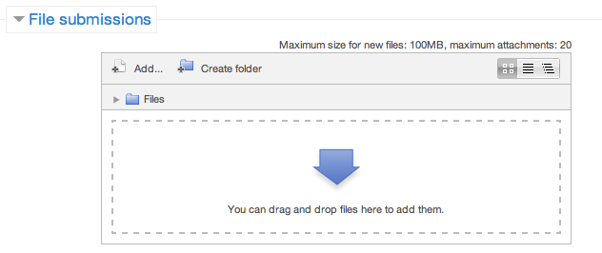

**Step 5** – Once the files are uploaded, click ***Save Changes***

**Step 6** – If you are ready to submit click ***Submit Assignment***

**Step 7** – Click ***Continue*** – this will send your document for grading and you will not be able to make further changes.

**Safety Hazards**

In the table below identify all the potential hazards in your workplace. A minimum of 20 is required.

|  |  |  |
| --- | --- | --- |
|  |  |  |
|  |  |  |
|  |  |  |
|  |  |  |
|  |  |  |
|  |  |  |
|  |  |  |
|  |  |  |
|  |  |  |
|  |  |  |
|  |  |  |
|  |  |  |
|  |  |  |
|  |  |  |

**Safety Action Plan**

Take 5 hazards from your list above complete the safety action plan to manage each hazard.

|  |  |  |  |
| --- | --- | --- | --- |
| **SAFETY ACTION PLAN** | | | |
| **Safety issue or hazard** | **Action  required** | **Person  responsible** |  |
|  |  |  |  |
| ***Eg. Minor***  *Power cords for computers left across the floor* | *Contact IT Department to run wires through the wall* | *Jane* | **Date of action to be completed** |
| *Immediate* |
| **Review date & comment** |
| *Every 6 months* |
| **Catastrophic** |  |  |  |
|  |  |  | **Date of action to be completed** |
|  |
| **Review date & comment** |
|  |
| **Major** |  |  |  |
|  |  |  | **Date of action to be completed** |
|  |
| **Review date & comment** |
|  |
| **Moderate** |  |  |  |
|  |  |  | **Date of action to be completed** |
|  |
| **Review date & comment** |
|  |
| **Minor** |  |  |  |
|  |  |  | **Date of action to be completed** |
|  |
| **Review date & comment** |
|  |
| **Insignificant** |  |  |  |
|  |  |  | **Date of action to be completed** |
|  |
| **Review date & comment** |
|  |

**Training Plan**

Not all risks can be managed immediately. There are some that need to be accepted as part of our day-to-day activities. We need to develop and implement training for staff to know how to deal with these risks.

**Identify 5 hazards like this in your workplace. If there is already training in place, specify it, but also describe what further training might be required for staff.**

|  |  |  |
| --- | --- | --- |
| **Issue or Hazard** | **What is in place?** | **What are the inadequacies and what is needed?** |
|  |  |  |
|
|
|  |  |  |
|
|
|
|  |  |  |
|
|
|
|  |  |  |
|
|
|
|  |  |  |
|
|
|
|  |  |  |
|
|
|

**Workplace Health & Safety Policies and Procedures**

**How will you communicate your Workplace Health & Safety findings and actions to all stakeholders?**

|  |  |
| --- | --- |
| **Stakeholder** | **My Communication Strategy** |
|  |  |
|  |  |
|  |  |