**The Step by Step Process to completing and uploading this assessment**

*Make sure you finish the Topic before attempting the template assessment.*

**Step 1** – Complete the template below and save in a safe place on your computer, taking care to complete all the blank spaces

*There will be multiple templates to complete as part of this Module. Once you have completed all the templates – you are ready to submit.*

**Step 2** – Enter the Submit Your Templates area of the Module.



**Step 3** – Scroll to the bottom of the page and click the ***Add Submission*** button

**Step 4** – Again scroll to the bottom of the page and *‘drag and drop’* your files into the box

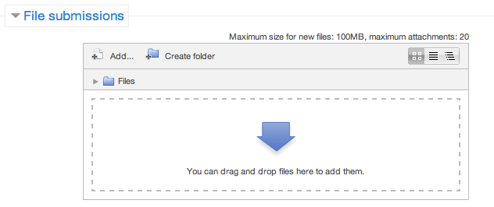

**Step 5** – Once the files are uploaded, click ***Save Changes***

**Step 6** – If you are ready to submit click ***Submit Assignment***

**Step 7** – Click ***Continue*** – this will send your document for grading and you will not be able to make further changes.

**Managing Risk In The Workplace**

**Risk Management Approaches**

Identify 5 risks assocaite with everyday operations in your team or department. Look back at ths Risk Rating Table to determine a grading for each risk and decide on your risk management approach to create straetgies for change for each risk

|  |  |  |  |  |
| --- | --- | --- | --- | --- |
| **Description of Risk** | **Likelihood** | **Consequence** | **Grade** | **Approach** |
|  |  |  |  |  |
|  |  |  |  |  |
|  |  |  |  |  |
|  |  |  |  |  |
|  |  |  |  |  |

**Risk Matrix**

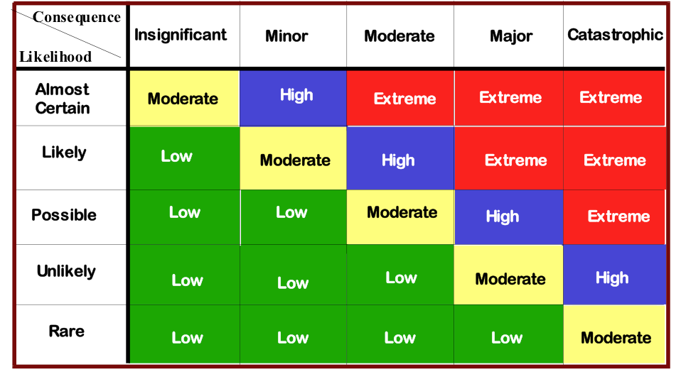

**Approaches:**

* Avoidance
* Reduction
* Retention
* Non-insurance transfers,
* Sharing
* Insurance
* Referral