**The Step by Step Process to completing and uploading this assessment**

*Make sure you finish the Topic before attempting the template assessment.*

**Step 1** – Complete the template below and save in a safe place on your computer, taking care to complete all the blank spaces

*There will be multiple templates to complete as part of this Module. Once you have completed all the templates – you are ready to submit.*

**Step 2** – Enter the Submit Your Templates area of the Module.



**Step 3** – Scroll to the bottom of the page and click the ***Add Submission*** button

**Step 4** – Again scroll to the bottom of the page and *‘drag and drop’* your files into the box

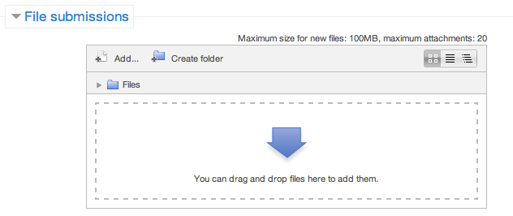

**Step 5** – Once the files are uploaded, click ***Save Changes***

**Step 6** – If you are ready to submit click ***Submit Assignment***

**Step 7** – Click ***Continue*** – this will send your document for grading and you will not be able to make further changes.

**Risk Management Plan**

**For My Department**

**Department:**

**Categories of Risk**

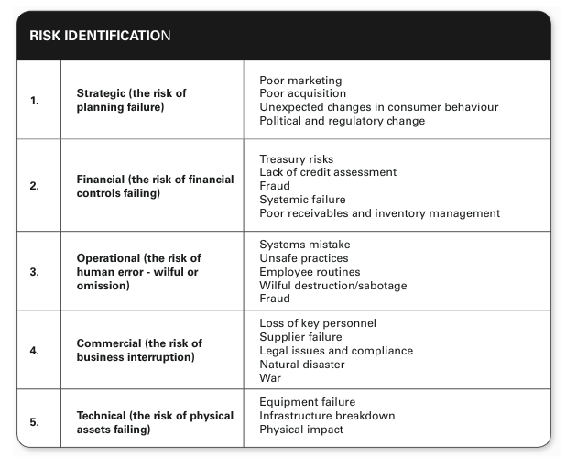

**Evaluating Risk**

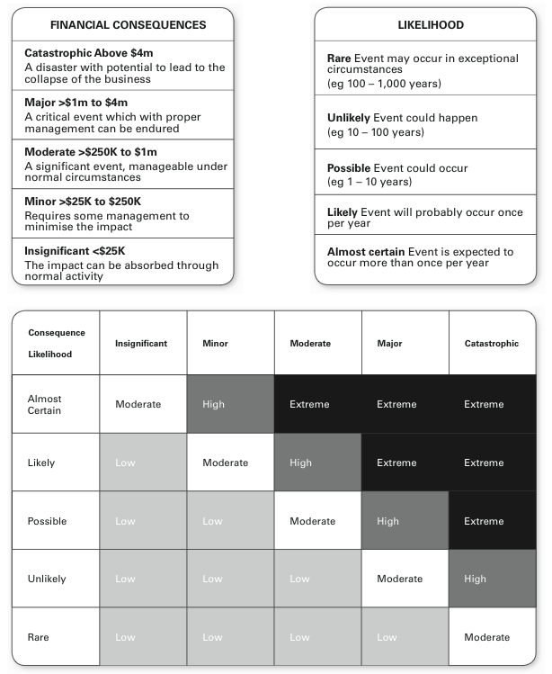

**Risk Management Plan  
Risk Identification**  
  
In the table below Identify 3 risks for each category of risk and evaluate the likelihood and consequence.

|  |  |  |  |  |
| --- | --- | --- | --- | --- |
| **Risk Identification** | | | | |
| **Type** | **Risks** | **Likelihood** | **Consequence** | **Grade** |
| *eg. Technical* | *Production machinery has  a major malfunction* | *Unlikely* | *Major* | *Major* |
| 1.  Strategic |  |  |  |  |
|  |  |  |  |
|  |  |  |  |
| 2. Financial |  |  |  |  |
|  |  |  |  |
|  |  |  |  |
| 3.  Operational |  |  |  |  |
|  |  |  |  |
|  |  |  |  |
| 4. Commercial |  |  |  |  |
|  |  |  |  |
|  |  |  |  |
| 5.  Technical |  |  |  |  |
|  |  |  |  |
|  |  |  |  |
| 6. Health and Safety |  |  |  |  |
|  |  |  |  |
|  |  |  |  |

**Risk Management Plan  
Risk Management Approach**  
**Decide on a risk management approach, implement and evaluate**  
(Identify 1 risk from each type and identify the action you will take)

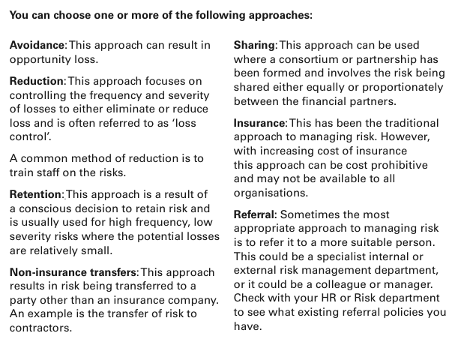

|  |  |  |  |
| --- | --- | --- | --- |
| **Risk Management** | | | |
| **Type** | **Risks** | **Action** |  |
| *eg. Technical* | *Production machinery has a major malfunction* | *A combination of Reduction Approach through Training on best practice of using machine and Non-Insurance Transfers by having regular maintenance performed by a 3rd party who then must supply back up procedures.* | **Implement When?** |
| *Begin training before purchasing machinery* |
| **Evaluate When?** |
| *Every 3 months* |
| 1.  Strategic |  |  | **Implement When?** |
|  |
| **Evaluate When?** |
|  |
| 2. Financial |  |  | **Implement When?** |
|  |
| **Evaluate When?** |
|  |
| 3.  Operational |  |  | **Implement When?** |
|  |
| **Evaluate When?** |
|  |
| 4. Commercial |  |  | **Implement When?** |
|  |
| **Evaluate When?** |
|  |
| 5.  Technical |  |  | **Implement When?** |
|  |
| **Evaluate When?** |
|  |
| 6. Health and Safety |  |  | **Implement When?** |
|  |
| **Evaluate When?** |
|  |

**Risk Management Plan**

**Risk Management Policy And Procedure**

|  |  |  |
| --- | --- | --- |
| **Risk Policy Procedures** | | |
| **Type** | **Risks** | **Policy and Procedure (rules)** |
| *eg. Technical* | *Production machinery has a major malfunction* | *- staff must complete online training course on machine before using*  *- 3rd party maintenance must be arranged every 2 months* |
|
|
|
| 1.  Strategic |  |  |
|
|
|
| 2. Financial |  |  |
|
|
|
| 3.  Operational |  |  |
|
|
|
| 4. Commercial |  |  |
|
|
|
| 5.  Technical |  |  |
|
|
|
| 6. Health and Safety |  |  |
|
|
|

**Risk Management Plan**

**Stakeholders**

How will you communicate your risk findings and actions to all stakeholders?

|  |  |  |
| --- | --- | --- |
| **Stakeholder** | **How can  they help  identify/analyse risks?** | **What & how will you  communicate  to them?** |
|  |  |  |
|  |  |  |
|  |  |  |

**Risk Management Plan**

**Evaluation**

**Do any of your risk management approaches increase potential risks in other parts of the organisation or operations? (min 200 words)**