**The Step by Step Process to completing and uploading this assessment**

*Make sure you finish the Topic before attempting the template assessment.*

**Step 1** – Complete the template below and save in a safe place on your computer, taking care to complete all the blank spaces

*There will be multiple templates to complete as part of this Module. Once you have completed all the templates – you are ready to submit.*

**Step 2** – Enter the Submit Your Templates area of the Module.



**Step 3** – Scroll to the bottom of the page and click the ***Add Submission*** button

**Step 4** – Again scroll to the bottom of the page and *‘drag and drop’* your files into the box

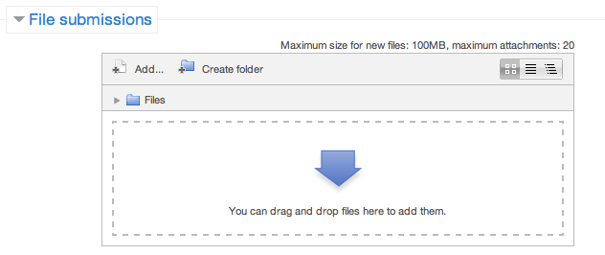

**Step 5** – Once the files are uploaded, click ***Save Changes***

**Step 6** – If you are ready to submit click ***Submit Assignment***

**Step 7** – Click ***Continue*** – this will send your document for grading and you will not be able to make further changes.

PLEASE NOTE THAT THERE ARE 5 QUESTIONS IN THIS TEMPLATE.

Using the links below research the body responsible for health and safety in your state.

* <http://www.worksafe.act.gov.au/health_safety> ACT - ACT Workplace Health and Safety Commissioner
* <http://www.workcover.nsw.gov.au/Pages/default.aspx> NSW - WorkCover NSW
* <http://www.worksafe.nt.gov.au/home.aspx> NT - NT WorkSafe
* <http://www.deir.qld.gov.au/workplace/> QLD - Workplace Health and Safety
* <http://www.workcover.com> SA - WorkCover South Australia
* <http://www.workcover.tas.gov.au> TAS - WorkCover Tasmania
* <http://www.worksafe.vic.gov.au> VIC - WorkSafe Victoria
* <http://www.safetyline.wa.gov.au/index.html> WA - WorkSafe Western Australia

**Q1. What are the relevant Acts / Legislation your state body provides information and assistance on?**

Answer:

Review the Safework Australia Model Codes of Practice: http://www.safeworkaustralia.gov.au/sites/swa/model-whs-laws/model-cop/pages/model-cop

**Q2. What are the codes of practice and how do they apply to you in your workplace?**

Answer:

**Q3.**

**The consistent message in each state is that the leaders within an organisation have a responsibility in each of the 5 key areas.**

**Complete the table below:**

|  |  |
| --- | --- |
| **Category** | **My Responsibility (What can I do?)** |
| Safe Premises |  |
| Safe Machinery & Materials |  |
| Safe Systems at Work |  |
| Information, Instruction,  Training & Supervision |  |
| Suitable Working Environment  & Facilities |  |

**Q4. Given these WHS legislative and regulatory requirements and your organisational requirements identify 4 areas you and your team need more training in:**

Answer: