**The Step by Step Process to completing and uploading this assessment**

*Make sure you finish the Topic before attempting the template assessment.*

**Step 1** – Complete the template below and save in a safe place on your computer, taking care to complete all the blank spaces

*There will be multiple templates to complete as part of this Module. Once you have completed all the templates – you are ready to submit.*

**Step 2** – Enter the Submit Your Templates area of the Module.



**Step 3** – Scroll to the bottom of the page and click the ***Add Submission*** button

**Step 4** – Again scroll to the bottom of the page and *‘drag and drop’* your files into the box

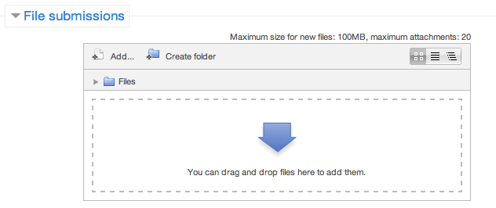

**Step 5** – Once the files are uploaded, click ***Save Changes***

**Step 6** – If you are ready to submit click ***Submit Assignment***

**Step 7** – Click ***Continue*** – this will send your document for grading and you will not be able to make further changes.

**Launchpad Leadership/Certificate IV Frontline Management**

**Reflective Paper**

## (1000 – 1500 words)

***Prepare a reflective paper on the whole Launchpad Leadership/Certificate IV Frontline Management program. This paper should include information relating to the main things that you gained from the program, how you have changed your thinking or behaviour and how you have been able to apply the knowledge and skills back into the workplace.***